

Digital Menu Application For Accessibility In Restaurants

Final Year Project Report

DT282

BSc in Computer Science International

### Angela Youyi Peng

### Oisin Creaner

### School of Computing

### Dublin Institute of Technology

### <Date>



Abstract

This application has the ability to integrate technology with dining, allowing restaurant owners to management their business in a modern and flexible manner. When correctly implemented this technology has the ability to not only increase customer satisfaction but also increase restaurant revenue.

Not only is this project focuses on the use of QR code but also allow users to integrate different languages whether for educational purposes or translation purposes. With this accessible feature tourists or language enthusiast can optimize this functionality when ordering food.

The goal of this application is to create an accessible food ordering system that enhances performance and efficiency. By researching the role of technology in the food industry, this application may allow users to take control and create a comfortable dining experience.

Declaration

I hereby declare that the work described in this dissertation is, except where otherwise stated, entirely my own work and has not been submitted as an exercise for a degree at this or any other university.

Signed:

_________________________

Angela Youyi Peng

<Date>

Acknowledgements

Body text

Table of Contents

Abstract 2

Acknowledgements 4

Table of Contents 5

Table of Figures 7

List of Tables 8

List of Code Snippets 8

1. Introduction 9

1.1 Project Background 9

1.2 Project Description 10

1.3 Project Challenges 11

1.3.1 Appropriate API Libraries 11

1.3.2 Back-End Database 11

1.3.3 Accessible User Interface Design 11

1.4 Project Objectives 12

1.5 Structure of The Document 13

2. Research 14

2.1 Background Research 14

2.2 Dining Experience 15

2.3 Similar Technologies 16

2.3.1 Order Wizard 16

2.3.2 Quick Orders 17

2.4 Technologies Researched 18

2.4.1 Front End Development (Native Vs. Web Vs. Hybrid) 18

2.4.1.1 Native Application 19

2.4.1.2 Web Application 19

2.4.1.3 Hybrid Application 20

2.4.2 Back End Research (Firebase Vs. SQLite) 20

2.4.2.1 Firebase 20

2.4.2.2 SQLite 21

2.4.3 Application Programming Interface and Libraries 21

2.5 Other Relevant Research 22

2.5.1 Customer Relationship Management (CRM) 22

2.5.2 Localizing User Interface 22

2.5.3 PayPal 23

2.5.4 Vision Impairment 23

3. Design 24

3.1 Methodology 24

3.1.1 Agile Methodology 24

3.1.2 User-Centred System Design Methodology 25

3.2 Use Cases and Iterations 27

3.2.1 Customer to Application Interaction 27

3.2.2 Customer to Staff Interaction 31

3.2.3 Staff to Server Application 33

3.2.4 Use Case Scenarios 35

3.2.4.1 Scenario A 35

3.2.4.2 Scenario B 36

3.3 Project Structure of Client Application 37

3.3.1 UI Components of Client Application 37

3.3.1.1 Layout Structure 37

3.3.1.2 Experience Designer 38

3.3.1.3 Colour Blind Accessibility 39

3.3.2 Package Structure of Client Application 41

3.3.2.1 Package Structure of Client App 41

3.4 Project Structure of Server Application 42

3.4.1 UI Components of Server Application 42

3.4.1.1 Layout Structure 42

3.4.1.2 Experience Design Server App 43

3.4.2 Package Components of Server Application 44

3.4.2.1 Package Structure of Server App 44

3.4.3 Overall Application Structure 45

4. Architecture & Design 46

4.1 System Architecture 46

4.1.1 Third Party APIs 46

4.1.1.1 ZXing Barcode Scanner 46

4.1.1.2 RetroFit2 REST API 47

4.1.2 Model View Controller (MVC) 47

4.2 Client Application Implementation 48

4.2.1 Activities 48

4.2.1.1 AboutActivity.java 48

4.2.1.2 BasketActivity.java 48

4.2.1.3 HomeActivity.java 49

4.2.1.4 LoginActivity.java 50

4.2.1.5 MainActivity.java 50

4.2.1.6 MenuDetailActivity.java 50

4.2.1.7 MenuListActivity.java 51

4.2.1.8 OrderPlacedActivity.java 51

4.2.1.9 ProfileActivity.java 51

4.2.1.10 ScanActivity.java 51

4.2.1.11 SearchFoodActivity.java 52

4.2.1.12 SeeReviewsActivity.java 52

4.2.1.13 SignUpActivity.java 52

4.2.2 Adapter 52

4.2.2.1 BasketAdapter.java 52

4.2.3 Application 52

4.2.3.1 LanguageApplication.java 52

4.2.4 Config 53

4.2.4.1 RemoteAPIService.java 53

4.2.4.2 RetroClient.java 53

4.2.5 Control 53

4.2.5.1 Control.java 53

4.2.5.2 Paypal.java 54

4.2.6 Database 54

4.2.6.1 Database.java 54

4.2.7 Helper 55

4.2.7.1 LocalHelper.java 55

4.2.7.2 NotifyMeHelper.java 55

4.2.8 Holder 55

4.2.8.1 MenuHolder.java 55

4.2.8.2 OrderHolder.java 56

4.2.8.3 ProductHolder.java 56

4.2.8.4 RestaurantHolder.java 56

4.2.8.5 ReviewHolder.java 56

4.2.9 Interaction 56

4.2.9.1 FirebaseMessage.java 56

4.2.9.2 FirebaseService.java 57

4.2.10 Model 57

4.2.10.1 MakeOrder.java 57

4.2.10.2 Menu.java 58

4.2.10.3 Response.java 58

4.2.10.4 User.java 59

4.3 Server Application Implementation 59

4.3.1 Activity 59

4.3.1.1 HomeActivity.java 59

4.3.1.2 MenuListActivity.java 60

4.3.1.3 OrdersPlacedActivity.java 60

4.3.2 Control 61

4.3.2.1 Control.java 61

4.3.3 Holder 61

4.3.3.1 MenuHolder.java 61

4.4 Back End Implementation 62

4.4.1 Database Structure 62

4.4.2 Firebase 64

4.4.3 SQLite DB Browser 66

4.5 Flow board of Activities 67

4.5.1 Client Application 67

4.5.1 Server Application 68

5. System Validation 69

5.1 Testing 69

5.1.1 Client Application Testing 69

5.1.2 Server Application Testing 69

5.2 Demonstration 69

6. Project Plan 70

7. Conclusion 71

Bibliography 72

Table of Figures

Figure 1 The Dining Experience Lifecycle 18

Figure 2 Order Wizard 19

Figure 3 Quick Orders 20

Figure 4 Quick Orders Operator 21

Figure 5 Android Jetpack 24

Figure 6 Agile Software Development Cycle 27

Figure 7 User Centred Design 28

Figure 8 Client Application UI Layout Structure 40

Figure 9 Language Menu 40

Figure 10 Adobe Experience Designer 41

Figure 11 Client UI Before Implementation 41

Figure 12 Client Application After Implementation 42

Figure 13 Red Weak Protanomaly 43

Figure 14 Green Weak Deuteranomoly 43

Figure 15 Blue weak Tritanomaly 44

Figure 16 Package Structure of Client Application 44

Figure 17 Server Application UI Layout Structure 45

Figure 18 Server Application Before Implementation 46

Figure 19 Server Application After Implementation 47

Figure 20 Package Component of Server Application 48

Figure 21 Model, View, Controller 51

Figure 22 PayPal Sandbox Credentials 57

Figure 23 Advanced Rest Client 60

Figure 24 Advanced REST Client FCM 62

Figure 25 Firebase Database Structure 68

Figure 26 DB Browser for SQLite 69

Figure 27 Flow Board of Client Application 71

Figure 28 Flow Board of Server Application 71

List of Tables

Table 1 Use Case of First Iteration 30

Table 2 Sequence Diagram of First Iteration 32

Table 3 Use Case Diagram of Second Iteration 34

Table 4 Sequence Diagram of Second Iteration 35

Table 5 Use Case Diagram of Third Iteration 36

Table 6 Sequence Diagram of Third Iteration 38

Table 7 Application Structure Diagram 48

Table 8 System Architecture Diagram 49

Table 9 Restaurant Data Structure Diagram 65

Table 10 Order Placed Data Structure Diagram 66

List of Code Snippets

Code Snippet 1 ZXing Barcode Scanner API 42

Code Snippet 2 Android Manifest Camera Permission 43

Code Snippet 3 RetroFIt2 REST API 43

Code Snippet 4 BasketActivity.java, Client App 44

Code Snippet 5 BasketActivity.java, Client App 45

Code Snippet 6 MainActivity.java, Client App 45

Code Snippet 7 MenuDetailActivity.java, Client App 46

Code Snippet 8 MenuDetailActivity.java, Client App 46

Code Snippet 9 MenuListActivity.java, Client App 46

Code Snippet 10 MenuListActivity.java, Client App 46

Code Snippet 11 OrderPlacedActivity.java 46

Code Snippet 12 Material Search Bar Library 47

Code Snippet 13 BasketAdaper.java, Client App 47

Code Snippet 14 LanguageApplication.java, Client App 48

Code Snippet 15 RemoteAPIService.java, Client APP 48

Code Snippet 16 RetroClient.java, Client App 48

Code Snippet 17 Control.java, Client App 49

Code Snippet 18 Paypal.java, Client App 49

Code Snippet 19 Database.java, Client App 49

Code Snippet 20 LocalHelper.java, Client App 50

Code Snippet 21 NotifyMeHelper.java, Client App 50

Code Snippet 22 FirebaseMessage.java, Client App 51

Code Snippet 23 FirebaseService.java, Client App 52

Code Snippet 24 MakeOrder.java, Client App 52

Code Snippet 25 Menu.java, Client App 52

Code Snippet 26 Response.java, Client App 53

Code Snippet 27 User.java, Client App 53

Code Snippet 28 HomeActivity.java, Server App 54

Code Snippet 29 HomeActivity.java, Server App 54

Code Snippet 30 MenuListActivity.java, Server App 54

Code Snippet 31 OrderPlacedActivity.java, Server App 55

Code Snippet 32 OrderPlacedActivity.java, Server App 55

Code Snippet 33 Control.java, Server App 55

Code Snippet 34 MenuHolder.java, Server App 56

Code Snippet 35 Firebase implementation 58

1. Introduction
   1. Project Background

The aim of this project is to assist individuals and businesses with flexible communication in the workplace. Ordering food through an application can be of great efficiency for both users and businesses with the aid of technology [1]. This application can assist users that may have anxiety in social environments to feel comfortable and enjoy their time at a restaurant without the need to interact directly with a waiter.

The real-time notification interaction between users and business provides a firm bridge of communication. Kitchen staff that can see orders placed are able to determine when the order is available to be served, this can be of great advantage to both customer and staff. The data from orders allows customers to keep on track of time and allows staff members to manage their business.

This project will consider many ways of user accessibility in design, implementation and development. A key feature to this project for efficiency is the use of QR codes. QR codes or also known as Quick Response codes have existed for over 15 years. Quick Response codes were first introduced by Denso Wave during 1994. It was used to enhance decoding speed and the ability to hold large amount of information. QR codes not only has the function of holding data but it is also a great marketing tool to draw in tech savvy audiences.

Internationalisation is a problem we face on a daily basis, with the aid of technology we are able to break that language barrier. By implementing a language setting into this application, we are giving a chance to open up the many possibilities of internationalisation. Allowing multiple languages can be of great benefit to broaden the business into the global market.

* 1. Project Description

This project will be divided into three parts, Client, Server and Administrator with two working application that communicates together to perform client-server interaction. The client application is used by a customer, server application is used by restaurant staff and the administrator provides system mantainance.

Client application uses many API libraries to perform tasks such as reading QR code, make order, make payments through the application and receive live updates on order status. Users can make payments through the app after an order is placed. Payments can be received by PayPal, credit card or cash transactions. Once the order is placed the details of the order is sent to the kitchen (Server Application). Here the restaurant staff are able to control the server side functionalities.

Server application will be able to manage order status and restaurant menus. Restaurant staff are able to receive a notification, notifying them of new orders, payment methods and extra details the customers may have noted in their order. Restaurant managers are able to add new dishes, edit current dishes and view orders.

Administrators are able to oversee all functionalities from the front and back end. They can provide new updated versions, fix bugs and setting up new restaurants and staff.

* 1. Project Challenges

Only having a basic experience with android application development there were many challenges faced during the development of this project. Below are some of the major challenges and issues that were encountered.

* + 1. Appropriate API Libraries

Choosing a precise API for certain functionality was a challenge as there are both pros and cons that needs to be considered. While choosing a third-party barcode scanner there where many libraries to choose from. Google Mobile Vision and ZXing barcode scanner were studied. At the end ZXing API was chosen because of its simplicity in use compared with google vision.

Retro Fit Representational state transfer (REST) API was a challenge to implement as data serialisation is performed by using a GSON converter. This took some time to understand, perfect its usage and syntax.

* + 1. Back-End Database

With a lack of prior knowledge in database storage that is suited for android applications other than SQLite, choosing a well performed backend service slowed down a significant amount of time in the development phase. This caused a great challenge but with determination of producing real-time data and notification services, Firebase was the best service to implement.

Although the main data storage is stored in firebase, SQLite Database Browser is also implemented in this system. Both databases have its own individual job and role in this application.

* + 1. Accessible User Interface Design

To implement a user-friendly interface that is accessible to users with colour blindness, choosing a colour palette was a great difficulty. Considering the different types of colour blindness and its statistics, deuteranomaly is one of the most popular kind which is a reduced sensitivity to green light. Research shows [1] that one in twelve men are colour blind. After testing out different colour combinations with a colour blind tool a simple solution is to set the contrast of colours and text to a 4.5:1 ratio.

Another accessibility that is implemented is the usage of a multilingual application. Localising application texts and data was a challenge that was faced. Since the menu items are stored in firebase, a second set of data needed to be added for a second language. This took an extensively long time as each data is added manually. Similar for any string texts that are shown throughout the application, strings of each language is manually added.

* 1. Project Objectives

The main objective of this project is to create an interactive order management system with the aid of QR codes. By using QR codes we are able to retrieve data efficiently from firebase backend. The objectives of the final product will be two application systems with the first one being for the restaurant manager and staff while the second primarily focuses on the customer.

Business should be able to perform basic management functions in this application. Management functions such as adding new categories, food items and viewing incoming orders etc. Allowing a productive and successful business to operative the following aims were considered:

* Developing an interactive system like updating order status.
* Developing fast and efficient menu management system which updates menus in real-time

Customers should be able to view menu details, place order and view order status. Like any food ordering application the basic functions applies. Payment transactions and table management details are some accessibility features that are implemented to this application. To accommodate user accessibility features for a smoother dining experience the following objectives were considered:

* Developing an application that can be integrated to another language.
* Developing a graphical user interface that fits a certain contrast ratio.
* Integrating descriptive language to buttons, text view and image view to aid talkback and braille back accessibility
  1. Structure of The Document
* Section 2 – Research

In this section, research in background, similar applications and technologies are conducted.

* Section 3 – Design

In chapter 3, the design implementation is discussed and how complementing colours play a major visual impact for colour blind users.

* Section 4 – Architecture & Development

This section, the architecture and implementation is discussed backed up with sample codes.

* Section 5 – System Validation

Testing will be conducted by users of little technical knowledge and tech savvy users.

* Section 6 – Project Plan

This section discusses the projects life cycle and any changes that were made during the course of this piece of application.

* Section 7 – Conclusion

To conclude, a reflection of the overall project, future plans and learning curve are discussed.

1. Research
   1. Background Research

In order to create a real-time client/server food ordering application, a deep understanding of the food and business industry is reviewed. A developer must become familiar to the environment for which the needs of both the customer and business are considered. The role of technology has influenced the restaurant industry drastically in recent years and it has become a part of most modern restaurants.

For a business, it is important to understand its market and acknowledge the connection with its consumers. Flexibly is the key to a successful business, by implementing technology into the food and drink industry we are able to establish this connection. An application that captures user detail and functions subjected to flexibility can build a trusted foundation between the producer and consumer.

Technology can be of benefit to both potential customer and restaurant operators. Customers can benefits include improvements in convenience and control, while restaurants can take advantage of improvements of service speed, reduction of labour costs, increase in revenue and enhancement in overall product quality.

Making the customer’s experience more convenient relates to the customers wish to sustain their time and effort. With an increase of accessibility substantially increases satisfaction. Technology can aid this convenience by providing functionalities to reduce wait time for customers when placing an order, transaction convenience can reduce customers wait time post dining and management convenience to increase the pace of an overall dining experience. When users have a certain control over a service, they are more likely to be satisfied with the final product.

Restaurants can benefit with the use of technology to increase the speed of service which in return more customers can be served. Table management, communication management and transaction management are some services that can increase the velocity of service which can almost guarantee a rise in customer satisfactory.

Technology in restaurants can also improve the business revenue. Adding accessibility in restaurants like a self-ordering system, will attract more customers resulting in an increase in revenue.

* 1. Dining Experience

Research shows how long customer’s dining experience should last. According to Noone, Kimes and Wirtz [2] study customers reaction changes based on the different stages from when a customer initially walks into a restaurant and the type of restaurant. The cycle of dining experience starts from when a customer walks into the restaurant.

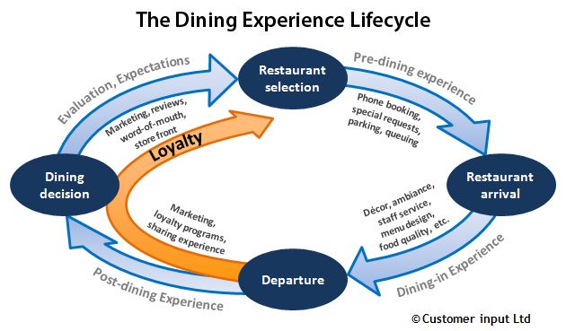

Figure 1 The Dining Experience Lifecycle [3]

In casual environments customers prefer a fast pre-dining and post dining stage yet during dining-in a slower pace is more desirable. Whereas customers at luxury restaurants are more likely to enjoy a slower paced dining experience.

Based on Noone, Kimes and Wirtz [2] study, restaurant managers should focus on these 5 methods to enhance revenue management:

1. Reduction of time during pre-dining phase.
2. Reduction of time during post dining phase.
3. Avoid reduction of time during dining-in phase.
4. Give customers the control of their dining experience
5. Focus on the importance of a consistence cycle throughout the whole lifecycle.

By acknowledging this cycle businesses can build a firm foundation to perform a smooth and satisfied experience for their customers.

* 1. Similar Technologies
     1. Order Wizard

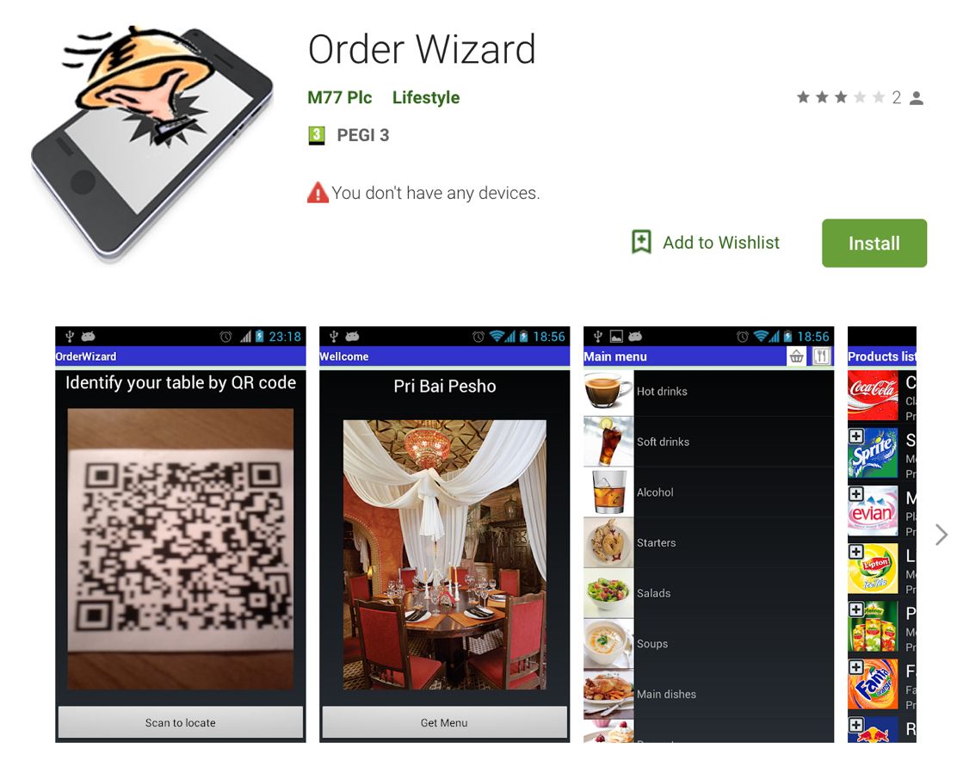

Figure 2 Order Wizard [4]

Order Wizard [4] has similar functions to this project including QR code scanning and processing payments through the application. This application supports both android and IOS system. The system will ask the user to scan a QR code to retrieve a restaurant, then depending on the restaurant a menu will display. From the menu, the user is able to add items to order, when they are finished they can then edit, delete or add extra details. Payments are completed by PayPal, offline cash or offline card transaction.

A benefit that this application take is users can call the waiter if they want to process the transaction with cash.

A disadvantage is that any extra details that the user adds is not by item but by the overall order. This application also does not ask for customer details this may cost a loss in clientele and security breach. User authentication provides secure transactions and personal information without this it becomes a vulnerability. The system will become exposed to cybercriminals from gaining personal information.

This application is available on google play but there haven’t been any updates since 2013 when the application was first created. The overall UI appearance is also out dated with a harsh black background and little creativity in design.

* + 1. Quick Orders

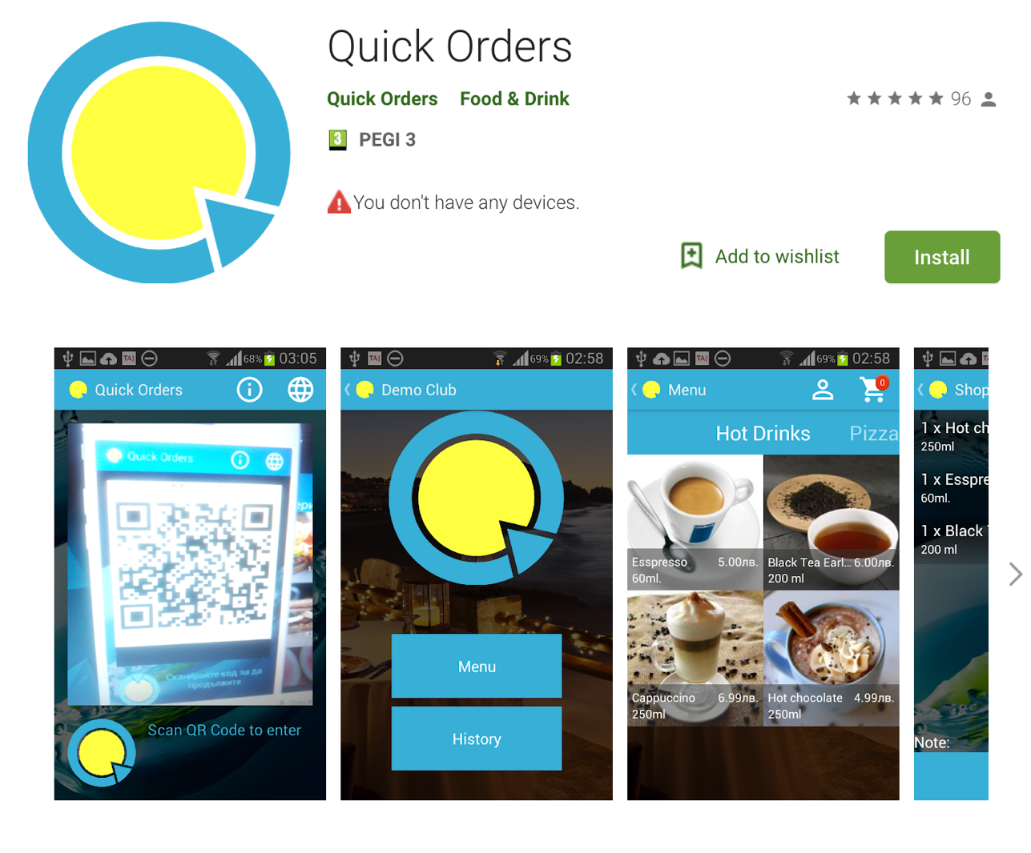

Figure 3 Quick Orders [5]

Quick Orders [5] is available on the google store and it has the functionality of a barcode scanner that supports all mobile operation systems. Similar to this project it has the ability to order through the application, add personal comments and see order histories. A key feature to this application is the multilingual functionality which is a great accessibility characteristic. With this feature, this application can be opened up to a larger global market.

A major advantage of this application is that it is multilingual. Being able to change and set the language according to the user. This feature provides access to users internationally which can help enterprises and businesses to expand their market globally.

A downside to this application is that there is no payment transaction through the app. Once the user places an order it doesn’t ask for confirmation which means any individual that has access to the QR code can make an order and not pay for it, this is a major flaw in the application. If the developer implemented a payment process it can allow quick transaction process and increase user authentication.

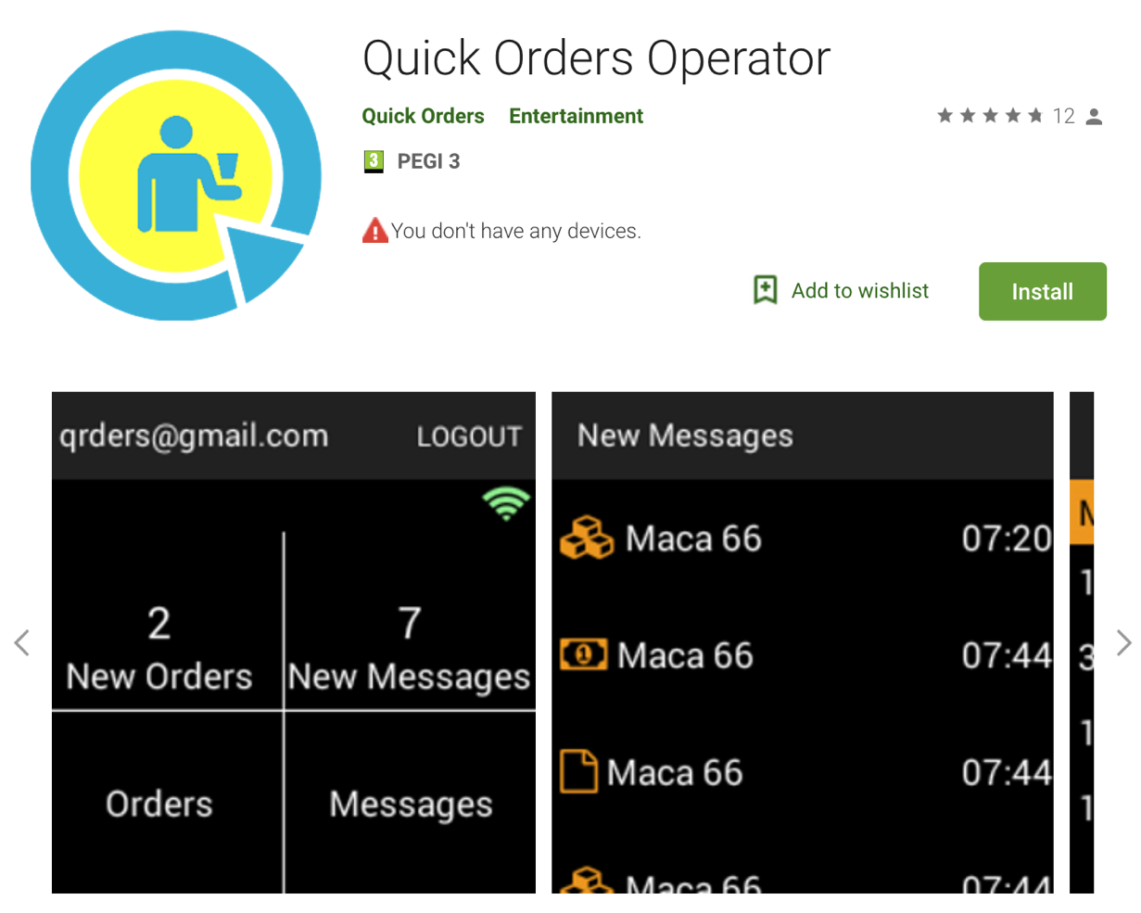

Figure 4 Quick Orders Operator [5]

The image above shows merchant side application which complements the customer app. This Quick Order Operator [5] shows restaurants or bars of incoming orders. It provides information about each order, item ordered, quantity and total amount.

A disadvantage to this application is that there are no functionalities for business management which is not as accessible for merchants. Through this application restaurant managers are not able to add, update or control dishes to their menu.

* 1. Technologies Researched
     1. Front End Development (Native Vs. Web Vs. Hybrid)

Developing a graphical front-end user interface native, web and hybrid development were considered. They each contain their own pros and cons list of usability features. The three types of front end development that were researched are discussed in detail below.

* + - 1. Native Application

As this project is concerning the development of an android application, android API’s native contains many tools that can be directly accessed through the IDE. Android studio depends on XML files for activity views and layouts. As the application is native to its platform XML files can be accessed in a fast and responsive manner.

Specific UI design which can be developed straight from the IDE can provide an overall better user experience. With additional device built-in features a more flexible interactive experience can be accomplished, giving the final product a much smoother transition and user input/output transactions.

Native application can also benefit users with mobile devices. Developing an application that can be used on a daily basis can increase revenue for businesses and a mobile phone application can provide that portability and efficiency in use.

Disadvantage of native applications includes the need of an extensive amount of knowledge in the programming language during development and maintenance phase. Native applications need constant software updates to fix any bugs that may occur or arises. Vast amount of time spent to implement the large amount of work that is expected to develop a flawless native application can in return sequentially cost a fortune to maintain.

* + - 1. Web Application

Web application hosted by web browsers are condensed information from the website to produce a more functional application that acts similarly to a native application. A wide range of technologies can be used to implement a web application this includes, open source platforms like angular.js and Node.js.

Advantages in developing a web application is its trouble-free methods to maintain and fix bugs without the user having to constantly update the application for new versions. Web applications can be accessible by all platforms through an internet connection which allows cross-platform application service. Cross-platform application can benefit both the user and developer. Users have that flexibility to view the application on any device, developers can primarily focus on perfecting the web applications functionalities and usability.

Security is a priority in web applications because unlike other simple websites, web applications are utilized on the machines dedicated server. Internet access is needed at all time, without it users cannot experience the application to its full potential.

Compared with native applications, web applications are much slower in use and less interactive for a user friendly design.

* + - 1. Hybrid Application

Hybrid applications is a combination of a native app and a web app. This is built by using a combination of JavaScript, HTML, CSS wrapper in a native container like, web view. Hybrid method is simple to develop and development time is significantly faster than native apps.

The key benefit of utilizing a hybrid application is that it allows access to different device platforms to be integrated which is therefore cost efficient. Consistent maintenance can be done without having the user update the application expect for any major changes.

Run time for native applications are much slower than native apps. They lag in many ways in navigation to different activities and interactions. Users cannot experience access to native features, this can be a downfall for UI design and programmatic operations.

* + 1. Back End Research (Firebase Vs. SQLite)

There are many back end servers that are available to use for developing an android application. The two most popular of them are firebase which can provide real-time data and android studio built in SQLite database. Below discusses the two databases usages and limitations in detail.

* + - 1. Firebase

Firebase [5] is a free cloud hosted service which can be used by application development as a backend server. Firebase offers many abilities to perform an interactive client-server operation.

Firebase database offers storing and synchronising real-time data to any connected devices of all platform. With this real-time data functionality notifications can be sent to targeted users using Firebase Cloud Messaging (FCM).

Because firebase follows the concept of JSON structured data this makes implementing with little back end development. Although the implementation cycle is simple, the design of the structure is far more complicated.

By using firebase authentication with phone/email and password, Facebook or google account can produce a more secure application to identifying a real user. It also allows the use of google analytics which provides a statistical view of the amount of active users.

* + - 1. SQLite

SQLite is an open source database service and it can be accessed using android studio IDE. SQLite requires no installation for this service because it is an in-process relational DBMS. Its lightweight structured file that uses relational query language enables SQL to retrieve data.

This database does not rely on server which means no configuration is required and internet usage is needed. Communications are directly with the application for this instance Android studio IDE. SQLite can only handle low to medium traffic which is not suitable for large data storing application.

* + 1. Application Programming Interface and Libraries

With the introduction of google play service 7.8, Mobile vision API released a new API which enables barcode scanner to read and decode its contents. Google barcode API is able to detect barcodes in real time on devices in any orientation. By implementing this with permission to use Camera API, an android framework which supports various camera features. This allows the application to access the device camera and scanning any barcode it detects.

ZXing [6] also known as “Zebra Crossing” is a google operated open source service which is used to read and decode barcodes using an image processing library.

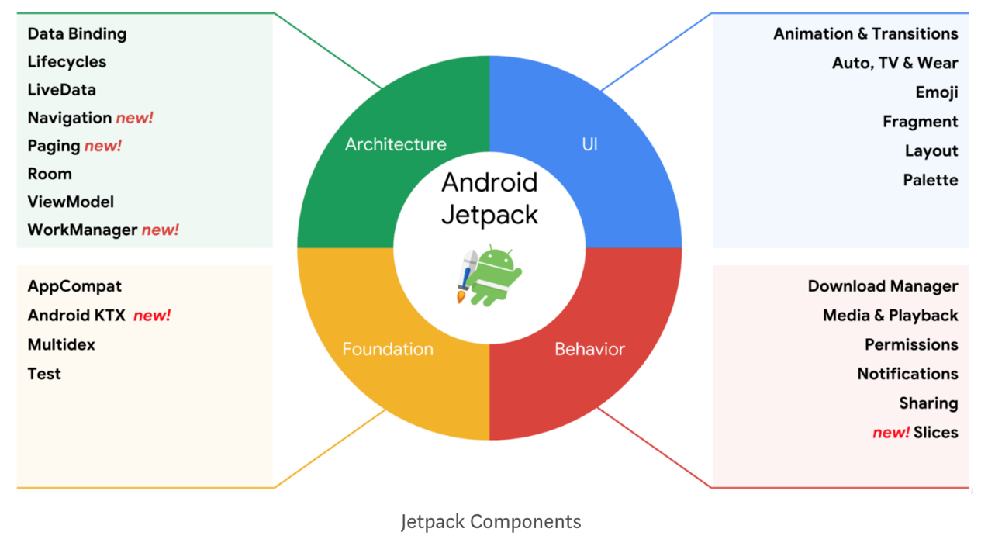

Figure 5 Android Jetpack

A migration from android to android jetpack [7] also known as androidX was performed to improve android studios library performances. AndroidX is a more improved set to utilize libraries, tools and frameworks to perform uniquely according to its developer. A quote from Alan Viverette [8] to summarize the usage of android:

*“Jetpack is a larger-scoped effort to improve developer experience, but AndroidX forms the technical foundation. From a technical perspective, it’s still the same libraries you’d have seen under Support Library and Architecture Components.”*

* 1. Other Relevant Research
     1. Customer Relationship Management (CRM)

Mobile customer relationship management (CRM) [9] is extremely important in today’s food industry. With the increase in the use of technology and internet services businesses ensures customers are receiving the best service at all time. Capturing client details allows employees to provide real-time data and information to clients immediately.

Benefits of customer relationship management is its ability to deliver performance reports, analytics in sales and organizational activities in businesses.

* + 1. Localizing User Interface

Advancement of technology made it possible to communicate with individuals of different nationality to interact with each other at ease. For instance, if a user that has many allergies is travelling and ordering food in a foreign restaurant becomes a difficulty an application that supports different languages can benefit these individuals. Therefore, the language barrier is not a problem when customers go to a non-English spoken country.

Android studio is able to localize the user interface to support different languages. By utilising translation editor in the IDE, it will allow the application to change from one language to another and not effecting the systems default language.

To implement translation properties, machine translation and human translation [10] mechanisms are studied. Machine translation provides many benefits, for one, it is less expensive than to hire a professional translator. Machine translation tools are becoming more and more reliable as data is fed into these software constantly but these improvements is still no match for a human translator. Human translators are relatively more reliable to translate texts into human read-able wording although it may cost dearly.

* + 1. PayPal

The most secure way of electronic transactions is through PayPal [11]. PayPal accepts payments using credit card and PayPal account transactions. By using HTTP based RESTFUL APIs, we can retrieve real-time data to authenticate credentials. Responses and requests are structured in JSON. PayPal Sandbox allows developers to create virtual business and personal credit card accounts with virtual money.

* + 1. Vision Impairment

Developing an application that allows flexibility and change in user interface can ease any conflict and intimidation for individuals with vision impairment. Colour schemes, amount of information displayed and navigation should all be considered when developing.

Many vision impairment accessibility features including Talk-Back and Braille-Back requires applications to be designed in a simple layout to accommodate these functions. When developing an accessibility application all these services are researched thoroughly.

1. Design
   1. Methodology

There are many different methodologies that are available to conduct a successful project management and product. Methodology itself is defined to be a system of methods used in a particular area of study or activity. Below discusses the two main methodologies that are implemented into this project:

* + 1. Agile Methodology

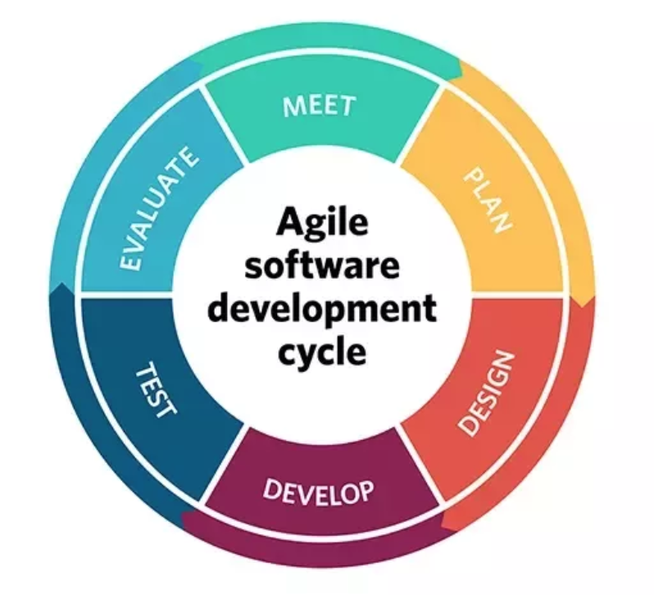

Figure 6 Agile Software Development Cycle

The agile methodology [12] is a method that provides quick and responsive feedback to developers in the direction the project is headed. During the development phase it has many opportunities to asset the project. The agile manifesto have four fundamentals values that are considered:

*“(1) Individuals and interactions over processes and tools*

*(2) Working software over comprehensive documentation*

*(3) Customer collaboration over contract negotiation*

*(4) Responding to change over following a plan”*

By implementing some aspects of agile methodology and principles, a valuable product was developed in a time efficient and organised manner. Agile process is customer focused and aligned with business needs.

Each step of agile methodology are taken into account and thoroughly performed to produce the final product of this application. To maintain a consistent flow of work, each day a new target is set and previous bugs were acknowledged. Following the cycle of agile methodology goals were achieved on a daily basis and performance of productivity also increased.

* + 1. User-Centred System Design Methodology

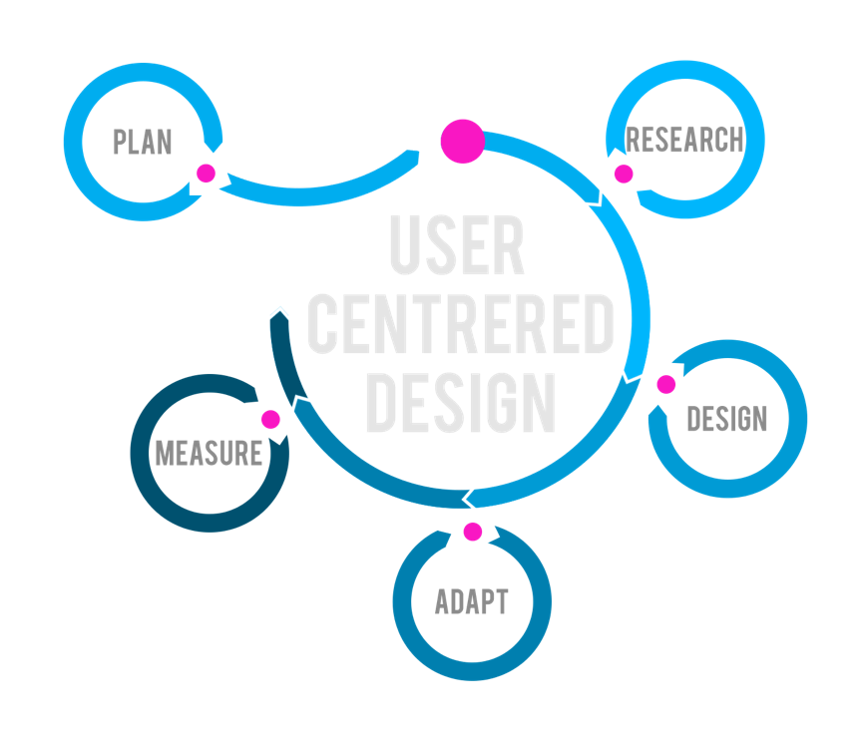

Figure 7 User Centred Design

User-Centred System Design (UCSD) [13] methodology’s focal point is usability throughout the entire development cycle and how it impacts users. Usability measures the productivity of the product and its efficiency and satisfactory to a targeted audience. There are ten key principles of UCSD to remain focused on usability:

1. Design for the users and their tasks
2. Maintain consistency
3. Usage of simple and natural dialogue
4. Reduce unnecessary mental effort by users
5. Provide adequate feedback
6. Provide adequate navigation mechanism
7. Let the user take charge
8. Present information clearly
9. Offer assistance
10. Error-free

While developing this application all of the above principles are implied, especially when designing the user interface. This was a challenge and countless of research and tests were conducted. Focusing on the accessibility usage for users many aspects to the visuals were considered. By following the path of UCSD a clear visual and navigation mechanism was designed.

* 1. Use Cases and Iterations

This section comprises of use case diagrams, sequence diagrams and their corresponding iterations. To understand each actors’ responsibilities, the following use cases and sequence diagrams can

* + 1. Customer to Application Interaction

The first iteration includes actions customers are able to perform when using this application. The process of customer upon registering and making an order will involve at least 2 actors, the customer itself and the restaurant staff.

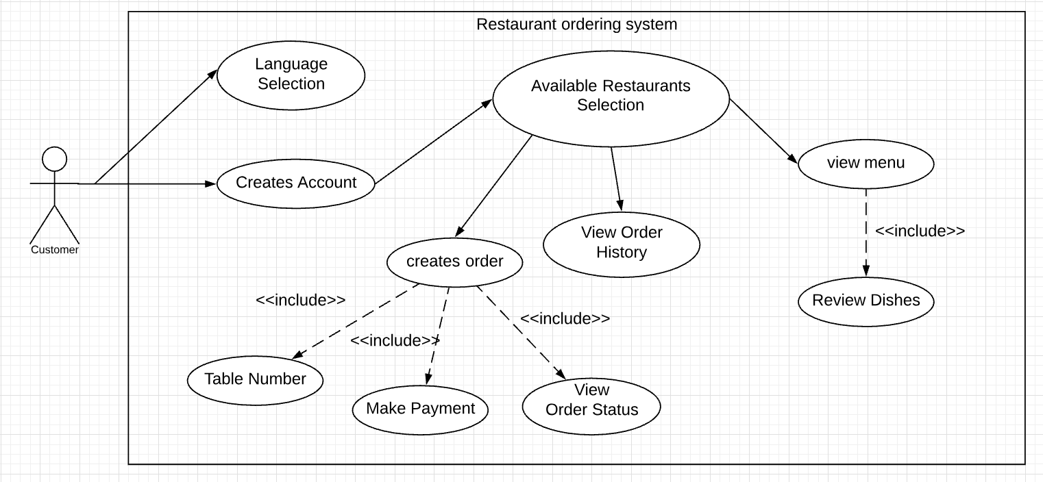

Table 1 Use Case of First Iteration

|  |  |
| --- | --- |
| Main Flow of First Iteration | |
| 1.1 | Customer creates account |
| 1.2 | Customer are able to change the language to their preferred |
| 1.3 | Customer are able to select a restaurant or scan a QR code |
| 1.4 | Customer are able to create order from menu items |
| 1.5 | Customer would need to input table number, comments, method of payment |
| 1.6 | Customer can make payment through the app by PayPal |
| 1.7 | Customer can view order status on their current and previous orders |
| 1.8 | Customer can view order history on selected restaurant |
| 1.9 | Customer are able to review dishes of menu items |

|  |  |
| --- | --- |
| Conditions of First Iteration | |
| Description | From the first iteration, we can see that the Customer is able to perform many tasks such as create account, make order, view menu and view order status. Customer must select an available restaurant in order perform certain tasks. |
| Pre-Condition | We know nothing about the user until the user has logged in or signed up. |
| Post-Condition | We know information about the user, selected language and order details. |
| Exception Errors | Some menu items cannot be translated. |
| Alternative variations | Users are validated by unique phone number and a corresponding password. Restaurant menu to view is validated by a QR code containing restaurant ID. |

Table 2 Sequence Diagram of First Iteration

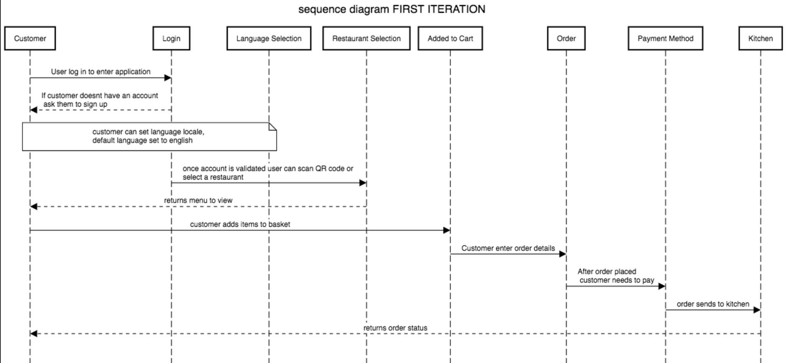

This sequence diagram shows the progression of actions performed by the customer when using this application. The user upon using the application they are able to set their favoured language or leave the default language to English. Users must log into an already existing account or create a new account. Inputs will be validated using firebase phone and password authentication.

Once the user is able to access their account they are able to use the application freely. If the customer wish to use the QR code functionality, they must first allow the application to access their mobile device camera to perform barcode scanner capability otherwise users can select available restaurants listed. After selecting a restaurant, the menu activity is shown and from here the user can add items into their cart.

Once the user is finished with their order they must specify the table number they are seated at and pay the total amount that is owed before the order goes to the kitchen. Users will be asked to select either cash or PayPal methods of payment.

Subsequently, when the transaction process is successful order will be sent to the kitchen await to be confirmed. The user then will be able to track their order based on order status. This status is changed manually by restaurant staff until the food is served.

* + 1. Customer to Staff Interaction

Second iteration is the actions performed between restaurant staff actor and customer. Staff have limited access to information about the restaurant itself and customers. Staff roles include payment confirmation, order status change and cook/serve dishes.

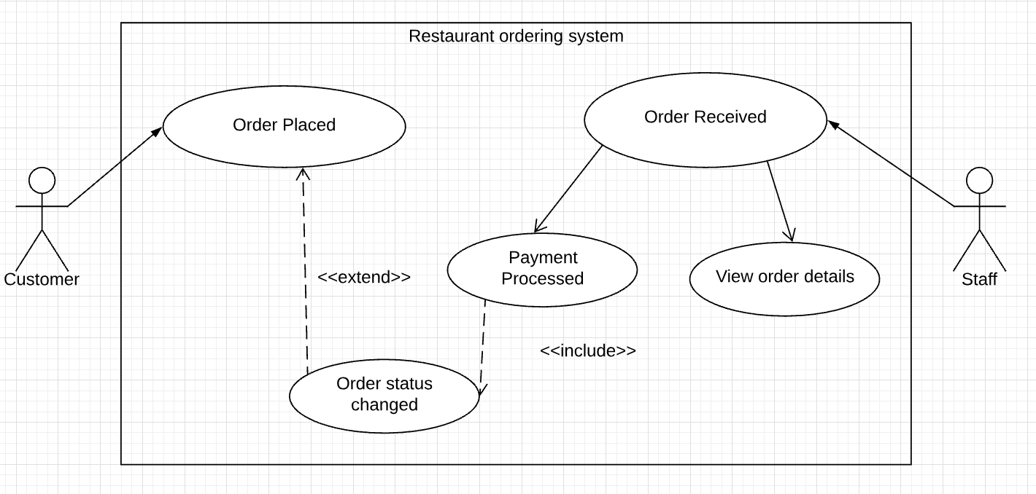

Table 3 Use Case Diagram of Second Iteration

|  |  |
| --- | --- |
| Main Flow of Second Iteration | |
| 2.1 | Customer places an order that get sent to staff |
| 2.2 | Staff receives order detail |
| 2.3 | Staff confirms payment process is complete |
| 2.4 | Staff are then able to view item quantity and comments from order |
| 2.5 | Staff can change order status |
| 2.6 | Order status when changed notifies customers |

|  |  |
| --- | --- |
| Conditions of Second Iteration | |
| Description | The second iteration shows the staff and customer. The staff can see the order placed by customers and transaction progress. Staff can change order status. |
| Pre-Condition | We know information about each staff. Staff does not know any information about customer. |
| Post-Condition | Staff knows customers order details. Staff knows order status, payment method and payment process. |
| Exception Errors | The chef can only start cooking if transaction process is completed. |
| Alternative variations | All staff must log into the staff account to keep track of incoming orders and status. |

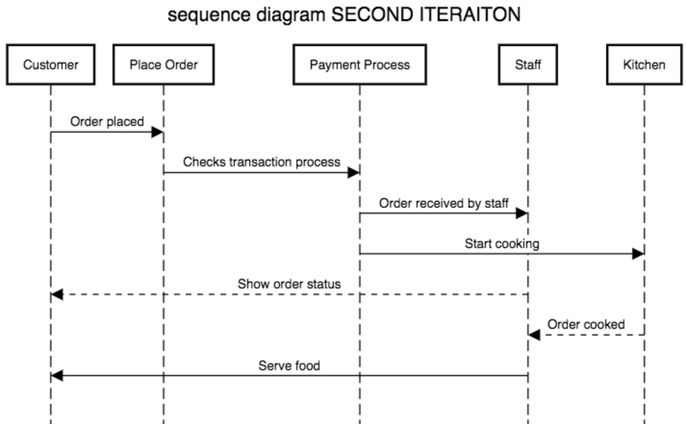

Table 4 Sequence Diagram of Second Iteration

Sequence diagram shown above sets a sequence of actions taken between customer and staff. When customers makes an order, payment verification is validated to ensure success transaction process. Once the transaction process is successful restaurant staff will start cooking orders placed. Staff will send order status of each stage of preparation, cooking and delivery process. Alerts sent to customer, notifies them of order status. Once kitchen staff have finished preparing the order, waiter will then serve the food to customers.

* + 1. Staff to Server Application

The third iterations involves restaurant manager only. They have certain roles to control and manage information about their business. They are able to perform CRUD operations to dish categories and menu items. Managers are able to view dish ratings that customers make, acknowledging of what to improve about their dishes. The manager runs the restaurant therefore, have the ability to control the environment.

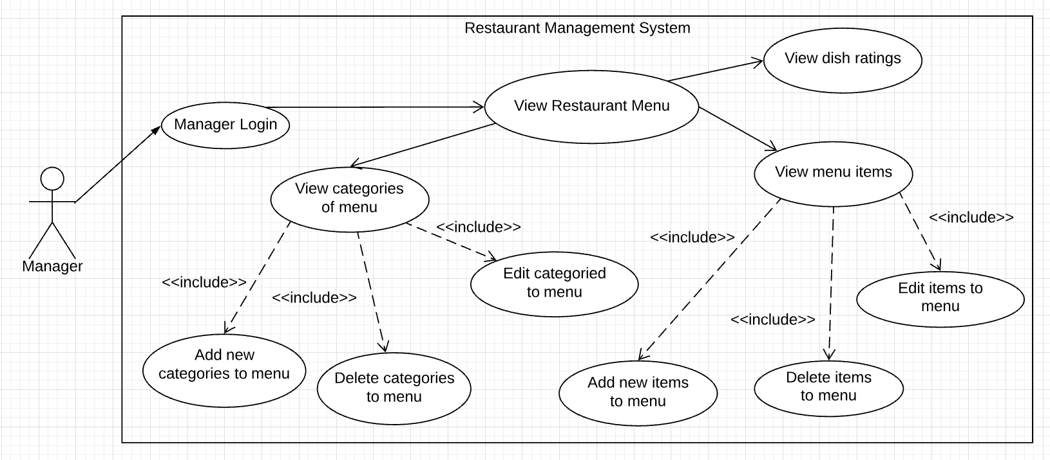

Table 5 Use Case Diagram of Third Iteration

|  |  |
| --- | --- |
| Main Flow of Third Iteration | |
| 3.1 | Managers must login as manager to access management system |
| 3.2 | Managers can view restaurant menu |
| 3.3 | Managers can view dish ratings by customers |
| 3.4 | Managers can add new categories |
| 3.5 | Managers can delete categories including dishes that are in a particular category |
| 3.6 | Managers can edit name and image of categories |
| 3.7 | Managers can view menu items |
| 3.8 | Managers can add new dishes |
| 3.9 | Managers can delete menu items |
| 3.10 | Managers can edit menu items price, name, image and description |

|  |  |
| --- | --- |
| Conditions of Third Iteration | |
| Description | The third iteration will contain the details of roles the restaurant manager. The manager can create, view, update and delete menu items. Managers are responsible for menu management. By capturing customer details in the first iteration managers can view customers review on particular dishes. |
| Pre-Condition | Managers knows information about menu items. |
| Post-Condition | Managers can view customer reviews and new menu items added. |
| Exception Errors | Managers cannot control QR code generation |
| Alternative variations | Managers must log in as restaurant manager |

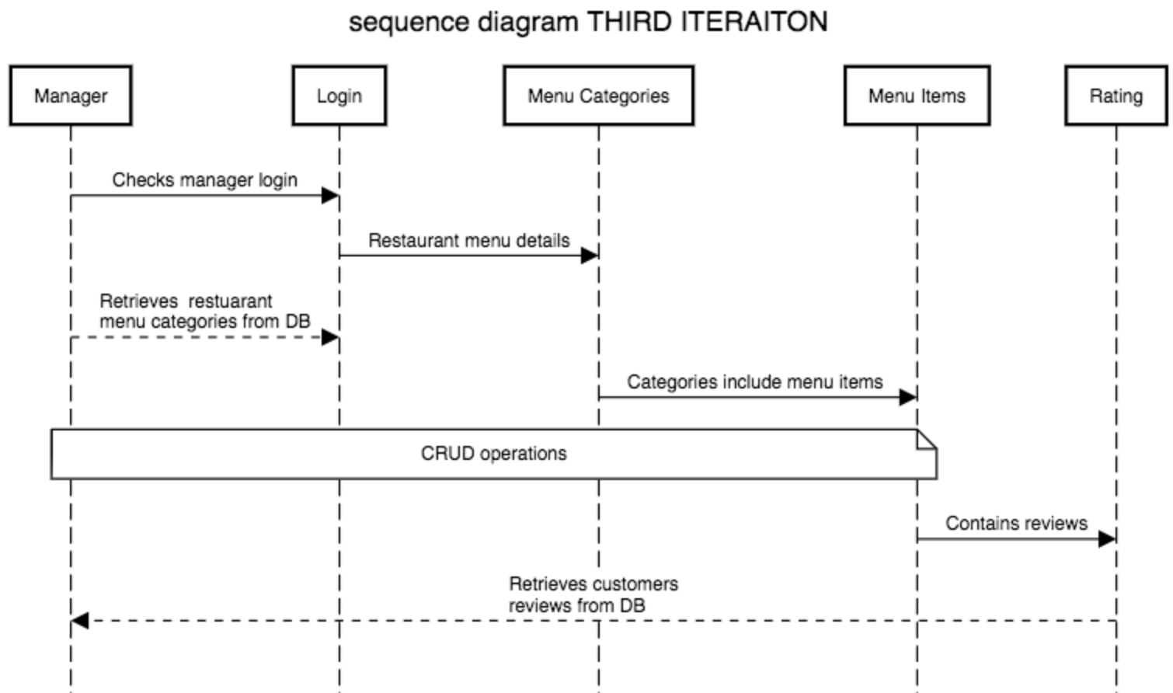

Table 6 Sequence Diagram of Third Iteration

Managers upon login is greeted with restaurant menu categories which can perform create, read, update and delete (CRUD) operations. Categories also includes menu items which also has functionality of CRUD on each dish.

Each dish contains reviews and ratings made by customers that can be accessed by managers. This can improve restaurant performance and provides feedback mechanism for restaurant managers.

* + 1. Use Case Scenarios

#### Scenario A

User A comes across a modern casual restaurant of interest. But this user suffers from an inability to speak which makes it difficult to communicate to other individuals. From pre-dining the restaurant advertises a new form of dining with the aid of technology. User A can feel more confident with the use of an application to order food in store while not having to interact with a waiter but still being able to experience a nice meal at a social environment.

User A upon entering the restaurant scans the QR code that is available to scan on a table which will guide them through the restaurant menu application. Once user A has made an order they can make their payment through the application, again relieving user A with any miscommunications and allows user A to control the duration of their dining experience. After the payment is processed the kitchen staff will keep the user updated with their order status.

User A received the dishes that were ordered and feels satisfied with certain dishes can rate the preferred dish to give the restaurant business feedback. As the order is already paid, user A can directly leave the restaurant after dining, making the post-dining experience convenient.

* + - 1. Scenario B

Assuming user B is tech savvy and has prior knowledge on using this application. User B is an extremely busy student that wants to use their meal time to be productive and not wanting any interruptions. User B uses this application in need of a quick and simple meal while still working. User B scans the QR code that is available and orders the items in the menu lists. With the in-app transaction system, user B doesn’t have to worry about waiting for the bill post-dining.

User B receives notifications from the kitchen staff of their order. User B’s dining experience allows them the time to both enjoy a meal at a restaurant at their own pace while still focusing on their college work.

* 1. Project Structure of Client Application
     1. UI Components of Client Application

#### Layout Structure

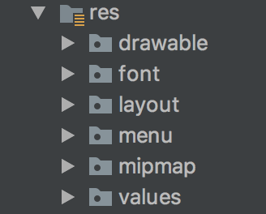

Figure 8 Client Application UI Layout Structure

Above shows android resource directory containing the packages of user interfaces structures. Each package contains different files to indicate each value and layout of certain activities. Below is a detailed description of each package:

“drawable”: Contains vectors/icons, images and background images that is used throughout the application

“font”: Main Activity layout contains a cursive font called Lucida Calligraphy.

“layout”: Contains android XML files that sets the graphical user interface that users can view.

“menu”: Contains XML files that are used within other layouts. This consists of selected menu items in navigation drawer and app tool bar drop down menu.

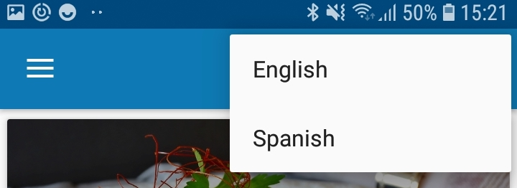

Figure 9 Language Menu

“mipmap”: Contains app launch icon.

“values”: Values package contains strings and styles of this project. Strings include different language strings. Styles includes app theme, collapsing toolbar, expanded toolbar and other unique customized styles.

#### Experience Designer

Adobe Experience Designer is a software that assists developers to design a visual prototype of their end product. This software is extremely beneficial to compare complementing colours and view colour to text ratio contrasts. A simple software can aid developers to design a user friendly graphical user interface



Figure 10 Adobe Experience Designer

Using adobe extreme design the initial user interface was outlined. Colour and layouts of button were designed which sets a outlined prototype. Below shows a comparison of the initial design using XD and the final design implemented with android XML.

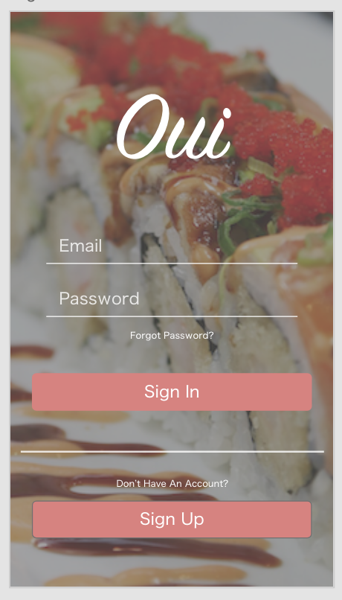

Figure 11 Client UI Before Implementation

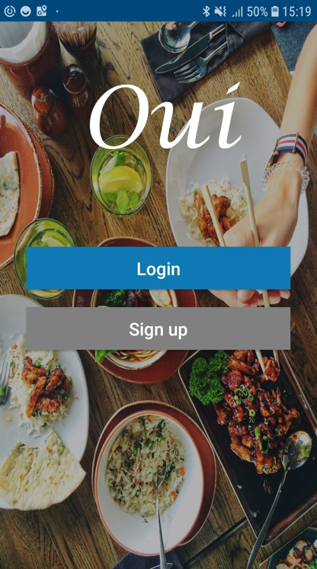

Figure 12 Client Application After Implementation

The comparison of the initial and final design both have similarities and differences. The main difference is the colour contrast. The prototype version seems too grey toned and is difficult to view the edit text inputs whereas the final product has distinctive, clearer images to differentiate the buttons.

* + - 1. Colour Blind Accessibility

While choosing the colour theme of the application, colour blind accessibility where taken into account. Using a colour blind filter program, views of different types of colour blindness was tested. Below are the results of the three categories of colour-blindness:

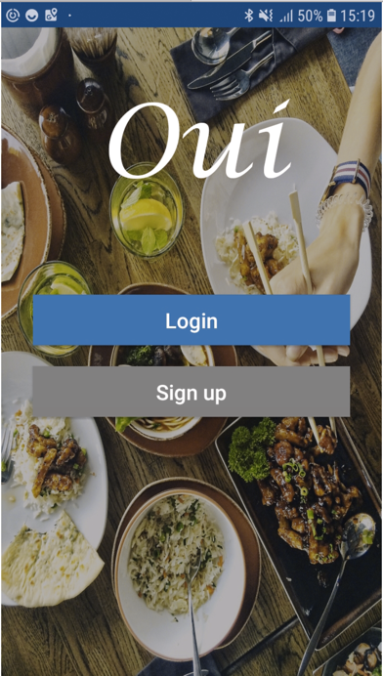

Figure 13 Red Weak Protanomaly

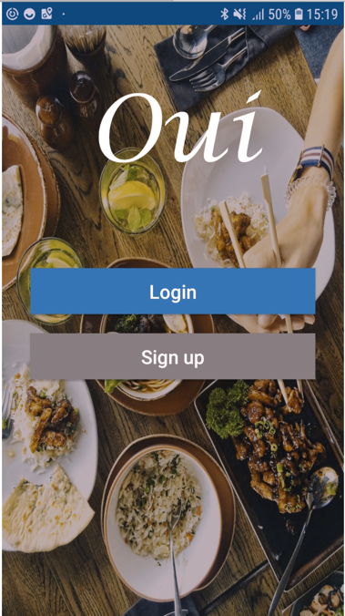

Figure 14 Green Weak Deuteranomoly

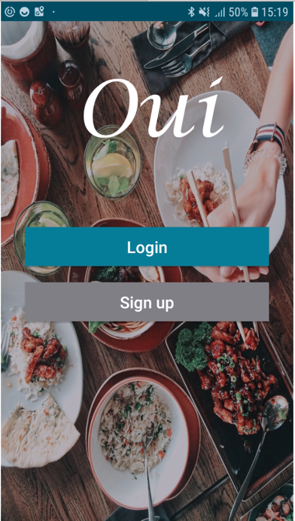

Figure 15 Blue weak Tritanomaly

* + 1. Package Structure of Client Application

In the main java resource directory contains all separate packages having common functionalities. Each package contains java files to perform certain roles in the application, below is a list of each package sorted in alphabetical order.

* + - 1. Package Structure of Client App

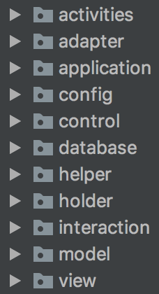

Figure 16 Package Structure of Client Application

“activities”: Contains all activities including its corresponding layout files.

“adapters”: Contains the java class for basket items that the user has added to their basket. This adapter package acts as a bridge between UI components and its functionality.

“application”: Contains the java class to integrate translation functionalities.

“config”: Config package short for configuration contains retrofit REST client service. Acts as a communication bridge between the two applications

“database”: Contains SQLite database helper that performs the SQLite queries.

“helper”: This helper package holds the java class to notification manager.

“interaction”: This package carries the classes for FCM, firebase cloud messaging services.

“model”: Model package holds classes that calls the data items. Using getters and setters.

“view”: View package contains an interface to set a listener.

* 1. Project Structure of Server Application
     1. UI Components of Server Application
        1. Layout Structure

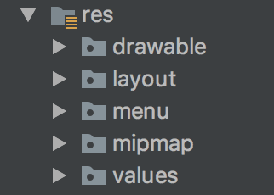

Figure 17 Server Application UI Layout Structure

Package layout of the resource directory are similar to client application with the exception of font package. Font is not an essential part of the server application, as implementing a clear and simple visual design to the merchant application provides uncomplicated guidance for clients. A simple and sophisticated design is implemented in the server application to increase business productivity.

* + - 1. Experience Design Server App

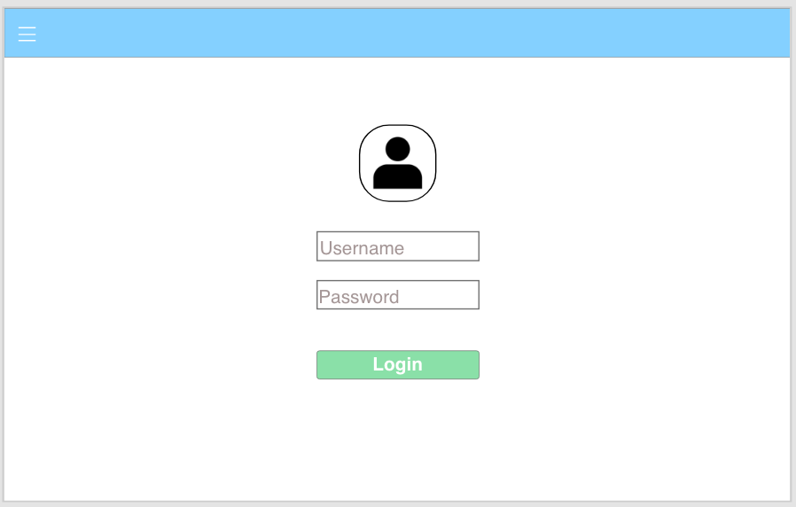

Figure 18 Server Application Before Implementation

Using Adobe XD an initial prototype of the server application was designed. Compared to the client application there is a substantial loss in visuals with a limited colour palette. Choosing a simple theme can stimulates productivity and using a white background representing neutrality. The result of a clean and minimalistic front-end design allows efficiency and smooth navigation which in return can increase business opportunities.

Initially, the server application is prototyped as a web application but after further research on restaurant businesses an android application is best suited. An android application is a lot more portable when working around a busy environment.

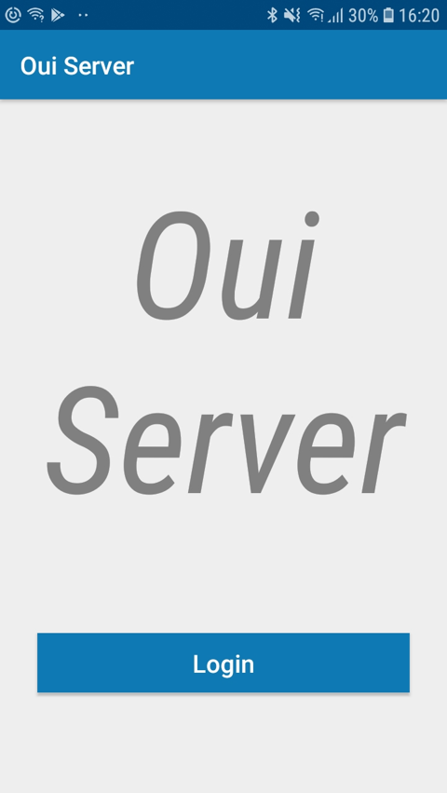

Figure 19 Server Application After Implementation

The image above shows the final design of the merchant application. Using similar colours with the client application, cerulean blue and a soft background colour a basic layout is designed.

Unlike the client application there is little graphics and visuals involved, this is because it enhances and increases productivity. To manage a business successfully there is no time to waste on irrelevant designs and implementations. Staying on track with as little distraction as possible can assure business owners productivity and success.

By keeping the user interface design to a minimal can enhance its main role and functionality as a restaurant management system. Staff has fast access to incoming orders without any distractions and complications.

* + 1. Package Components of Server Application
       1. Package Structure of Server App

The structure of server application is similar to the client application minus database package and application package. Database package is not needed because the main backend of the server application is firebase database. The application package is also not needed as the default language of restaurant management system is set in English although multilingual is not implemented in the server application it can be integrated in the future.

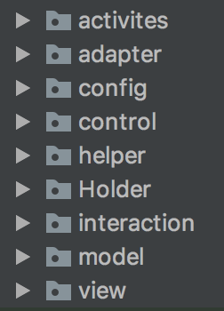

Figure 20 Package Component of Server Application

* + 1. Overall Application Structure

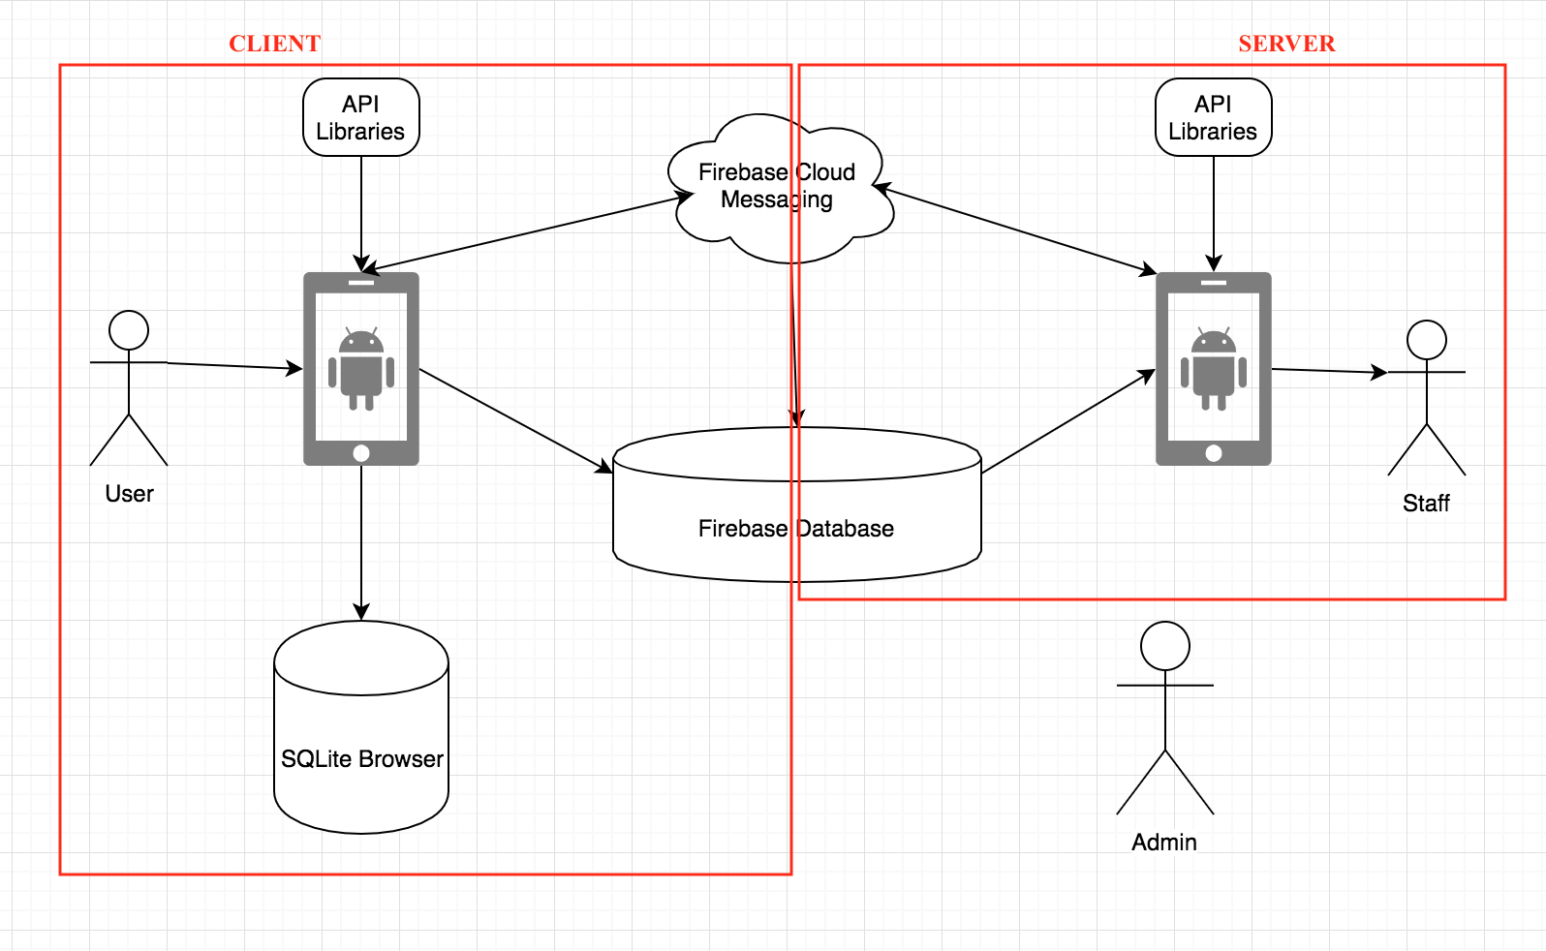

Table 7 Application Structure Diagram

The diagram above shows the overall project structure. There are three actors involved, user, staff and admin, each with their own roles.

* User operates on the client side application
* Restaurant staff operates menu management functionality and communicates directly with firebase database
* Admin monitors the whole system, maintaining system updates and fixes bugs

1. Architecture & Design
   1. System Architecture

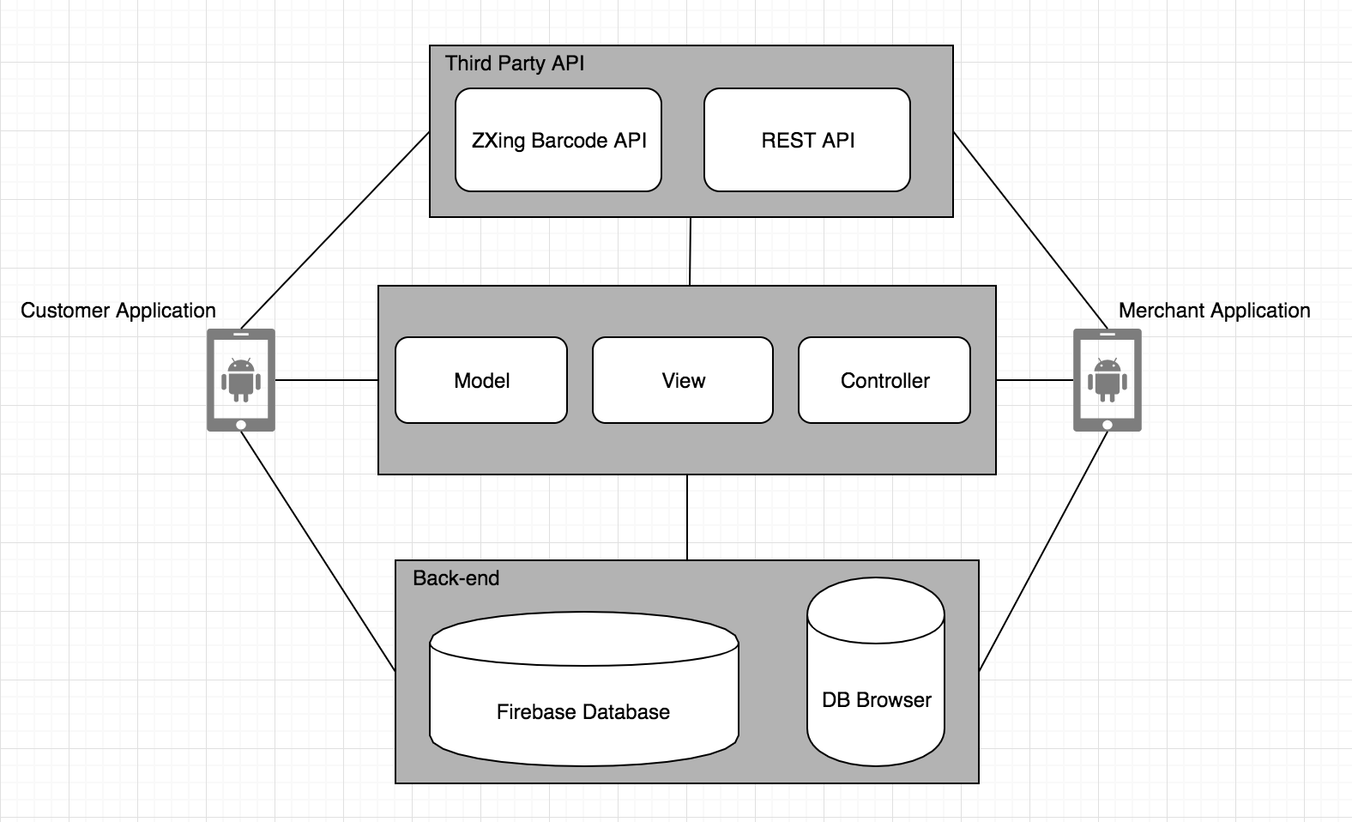

Table 8 System Architecture Diagram

The diagram above outlines the overall system architecture with the top layer consists of any third-party APIs used, the second layer shows MVC pattern of which the android environment is executed. Finally, the last layer is the back end where all the data is stored using firebase real-time database and DB Browser for SQLite. The diagram also shows the two application that is developed for customers and merchants. The whole system is then executed with an android operating system device.

* + 1. Third Party APIs
       1. ZXing Barcode Scanner

ZXing scanner or also known as Zebra Crossing is a fast and straightforward way to integrate barcode scanner library. By declaring the implementations below in the gradle file will allow the functions to implement a barcode scanner.



Code Snippet 1 ZXing Barcode Scanner API

In android manifest the following permissions were granted to authorize the device camera to be used.



Code Snippet 2 Android Manifest Camera Permission

* + - 1. RetroFit2 REST API

Retro Fit API is an open source library to enable HTTP communication for android applications developed by Square Inc. Retro Fit uses OkHttp to make requests, it also translates JSON responses to POJO (Plain Old Java Object). In order to do this translation data is sterilized by using a GSON converter factor. By initializing the following gradle implementations enables the use of this API with the aid of GSON converter.



Code Snippet 3 RetroFIt2 REST API

* + 1. Model View Controller (MVC)

The model view controller architecture (MVC) assisted me to design an interactive system that can be flexible to change. MVC consists of three parts, the first would be the model. The model communicates directly with firebase database which contains the data of the application any changes made to the model correspondingly changes the view to show the user of a new update. The second part is the view, this is the user interface displayed to the user which are developed in Android XML. The last part is the controller, this controls the user input and according to the inputs the view and/or model might changes.

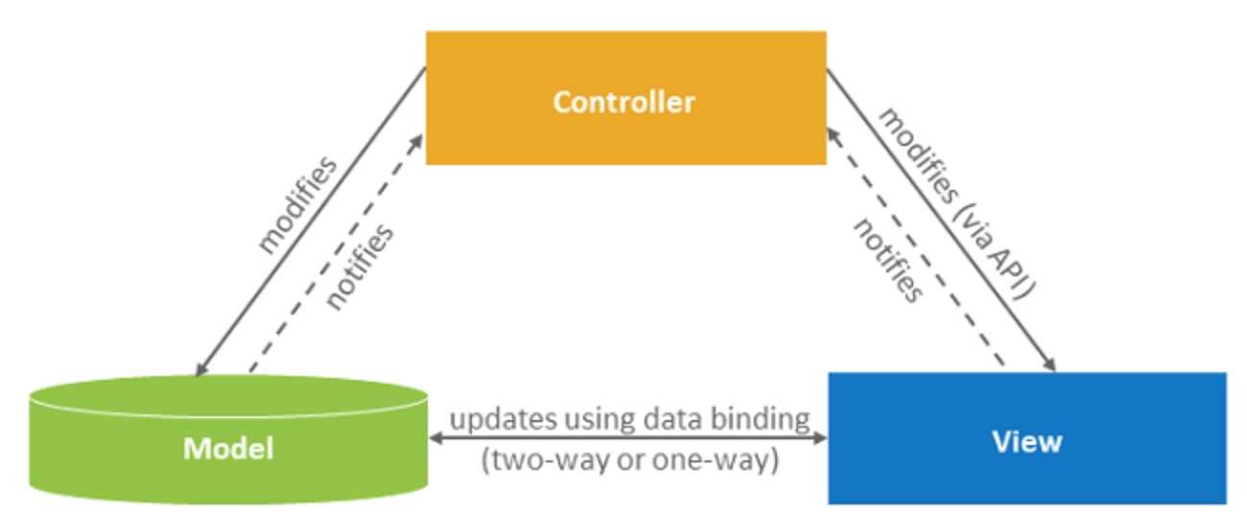

Figure 21 Model, View, Controller

From this architecture, the system will consist of the customer (view), the manager (view), database(model). The controller will update any data that has been changed by both views to model, once the update is done the views will automatically update. With the three environments working together it creates a smooth application.

* 1. Client Application Implementation
     1. Activities
        1. AboutActivity.java

About activity contains brief information about the selected restaurant and OUI application. A link containing the github repository of the application is shown here.

* + - 1. BasketActivity.java

Basket activity contains functions and information that is in the users shopping cart. The main ordering functionality takes place in this java file. Operations includes an Alert Dialog to enter table number, order comments and payment methods. The code snippet below shows PayPal transaction function is called, a new order is placed with the current date and time. paymentConfirmation.toJSONObject() will retrieve information for either the payment is processed or failed.

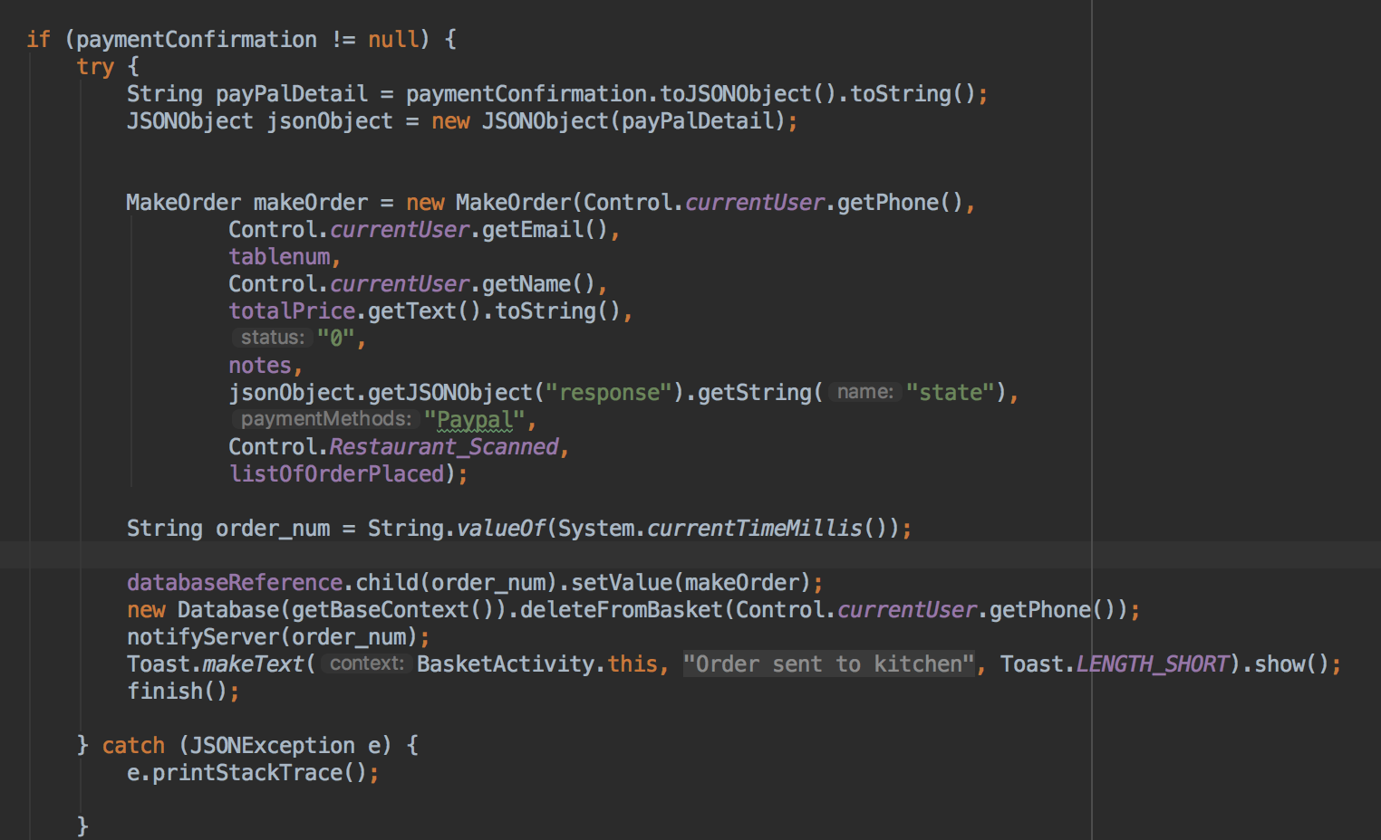

Code Snippet 4 BasketActivity.java, Client App

Following confirmation of the payment, notifyServer function is called. This function will send the remoteAPIService a token to notify the server application that an order has been placed using the call and response operations.

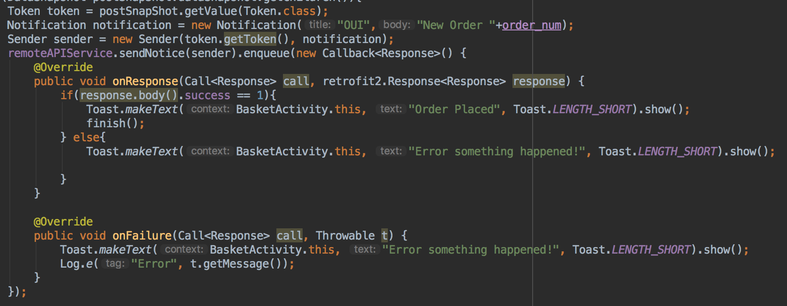

Code Snippet 5 BasketActivity.java, Client App

* + - 1. HomeActivity.java

Home activity contains a navigation drawer to guide users. In the main content of the home activity, a recycler view showing the restaurant menus categories. Users are able to see images of categories of foods.

On the top application bar there are two functions, the first is a search button that allows the user to search for all dishes in the selected restaurant’s menu. The second is a drop down menu which allows users to change the language of the application.

* + - 1. LoginActivity.java

Login Activity is a basic logging in functionality. Retrieving users data from firebase and compare the data with user input to authenticate users password.

* + - 1. MainActivity.java

Main activity consists of three buttons. The first button will bring users to the login activity on click, the second button brings the user to the sign up activity on click and lastly the third button opens an alert dialog that allows users to change the default language of the application.

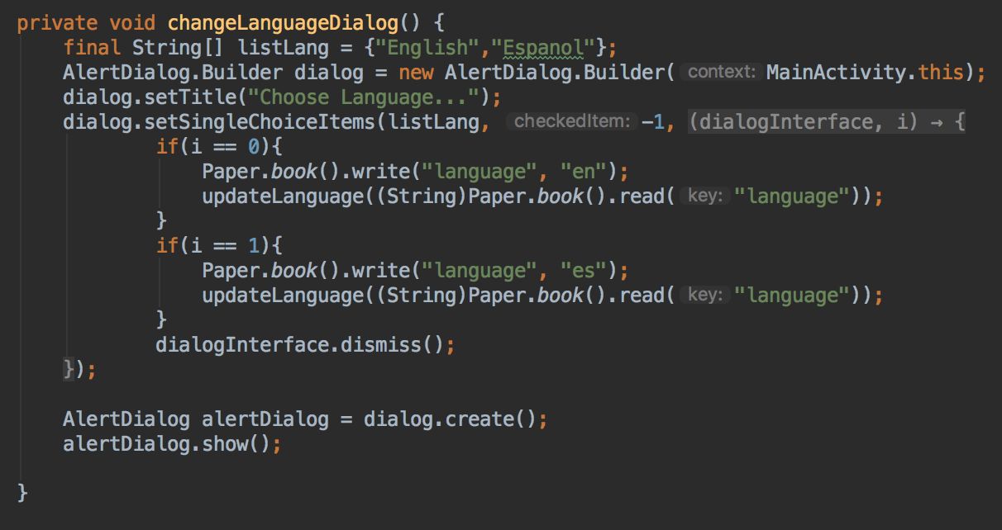

Code Snippet 6 MainActivity.java, Client App

* + - 1. MenuDetailActivity.java

Menu detail activity contains information about each dish including price, description and ratings. Customers are able to review dishes by utilizing the following function

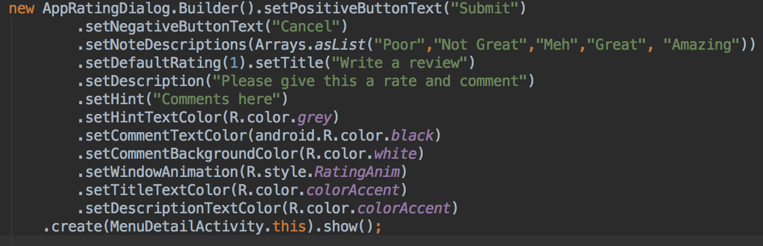

Code Snippet 7 MenuDetailActivity.java, Client App

Star ratings are shown based on the average rate of the sum of all ratings.

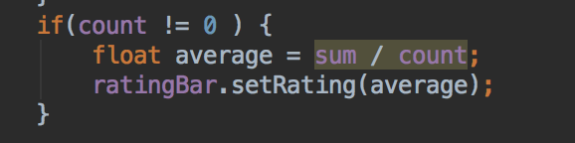

Code Snippet 8 MenuDetailActivity.java, Client App

* + - 1. MenuListActivity.java

Menu list activity contains a brief description and price of each dish on the menu. Retrieving data from firebase based on a selected restaurant ID.



Code Snippet 9 MenuListActivity.java, Client App

To view a list of items using recycler view FirebaseRecyclerOptions and FirebaseRecyclerAdapter must be declared



Code Snippet 10 MenuListActivity.java, Client App

* + - 1. OrderPlacedActivity.java

Order placed activity retrieves order history data from database, showing users of all orders placed previously at a selected restaurant. Users are able to cancel an order before the status of the order changes to ‘cooking in kitchen’.

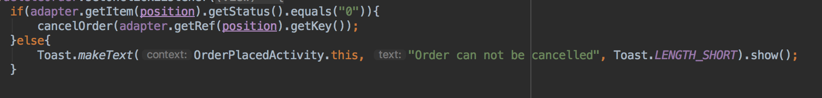

Code Snippet 11 OrderPlacedActivity.java

* + - 1. ProfileActivity.java

Profile activity shows users details such as name, email and phone number.

* + - 1. ScanActivity.java

This activity performs the barcode scanner using ZXing API library. For accessibility reasons a recycler view of available restaurants are listed. This activity allows users to either scan the QR code or choose a restaurant from the list if the user is not able to use the camera.

* + - 1. SearchFoodActivity.java

This activity performs search functionality on data that are stored in firebase. Material search bar is integrated into the design and implementation. Using material search bar, searching in large data storages can be more efficient and more interactive for the users. This search bar provides recent searches, auto-complete and listener for single value events.



Code Snippet 12 Material Search Bar Library

* + - 1. SeeReviewsActivity.java

See review activity, shows a list of reviews and comments about a certain dish at a certain restaurant.

* + - 1. SignUpActivity.java

Sign up activity provides a basic registration form. Once the user is signed up a verification code is needed to authenticate a user. This is sent by implementing firebase email and password authentication.

* + 1. Adapter
       1. BasketAdapter.java

Basket adapter extends recycler view <basketHolder>. Basket adapter holds a list of menu items there were added. Users can then delete an item from the basket by hold click on a selected item. With functions in basket activity java class operations of a shopping cart is implemented.

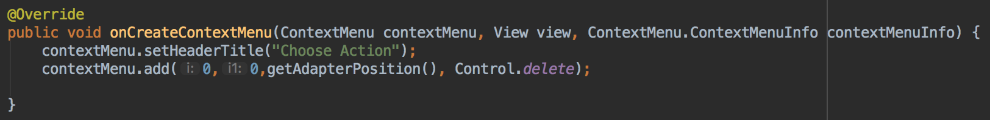

Code Snippet 13 BasketAdaper.java, Client App

* + 1. Application
       1. LanguageApplication.java

This file that extends application sets the default language to English. This acts as a base application file and is implemented throughout the activities that entails translation properties.

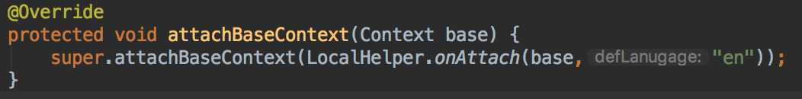

Code Snippet 14 LanguageApplication.java, Client App

* + 1. Config
       1. RemoteAPIService.java

HTTP requests are made in this interface from a remote API service, in this case Retro Fit. As declared in the header, the type of application and authorization key are set. Authorization key is the key that is set for this application on firebase cloud messaging(FCM) and can be found in firebase console.

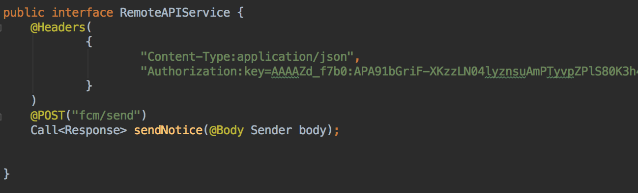

Code Snippet 15 RemoteAPIService.java, Client APP

To send notification HTTP requests directs all responses to FCM.

https://fcm.googleapis.com/fcm/send

* + - 1. RetroClient.java

In this java class conversion to GSON is created. This file provides the retro fit instance if it exists else a new instance is created and returned



Code Snippet 16 RetroClient.java, Client App

* + 1. Control
       1. Control.java

This file controls and stores temporary strings like current user ID and current restaurant ID. Control file is used throughout the activity files to set the data of users that is currently logged in and restaurants ID that the user has scanned.

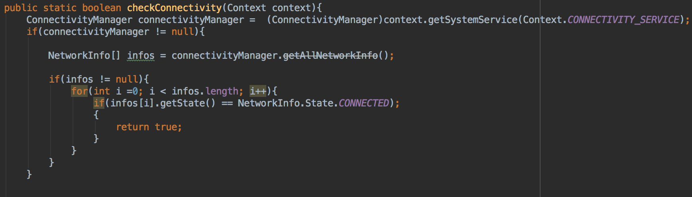

Code Snippet 17 Control.java, Client App

This file also implements the functionality of connectivity manager that is used to check for internet connection.

* + - 1. Paypal.java

Using PayPal sandbox developer an application is created. By storing the created PayPal ID.



Code Snippet 18 Paypal.java, Client App

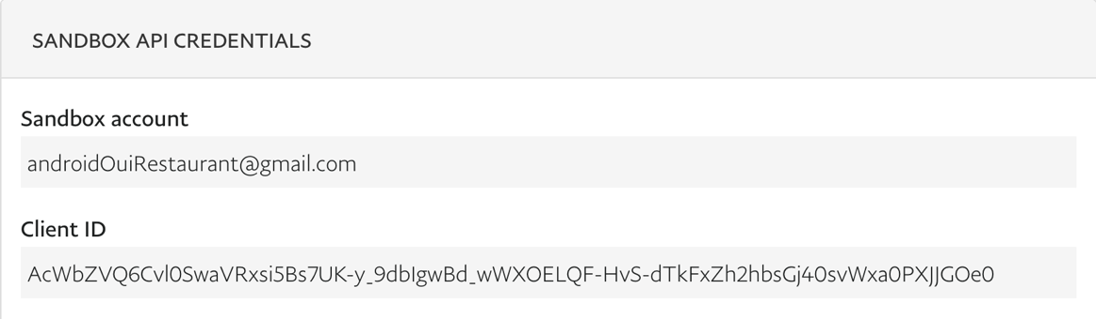

Figure 22 PayPal Sandbox Credentials

* + 1. Database
       1. Database.java

Database file extends SQLiteAssetHelper, this java file performs SQLite queries that loads basket items from SQLite DB Browser. Functions include add, delete and update basket items. The sample code below shows add to basket function that performs SQLite query.

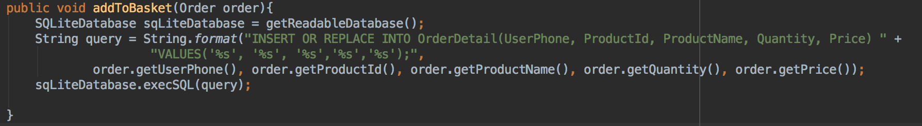

Code Snippet 19 Database.java, Client App

* + 1. Helper
       1. LocalHelper.java

To set the locale of the application Shared Preferences is implemented to store persistent data of a selected language.

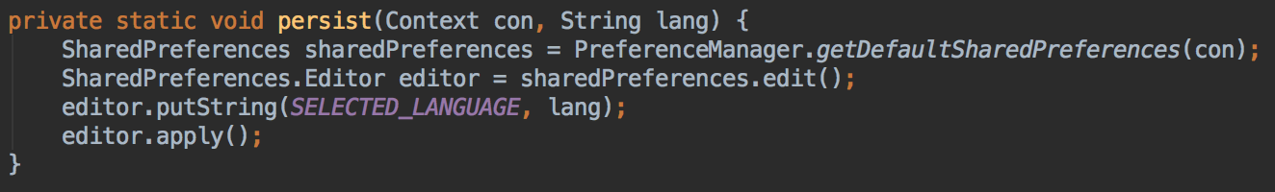

Code Snippet 20 LocalHelper.java, Client App

Shared Preferences are key-value pairs of primitive data types that are saved in a file within an app file structure. In this case, the file that is stored contains string texts of different languages.

* + - 1. NotifyMeHelper.java

Notification helper contains functions to create notification channel which enables android devices of incoming notifications from the server.

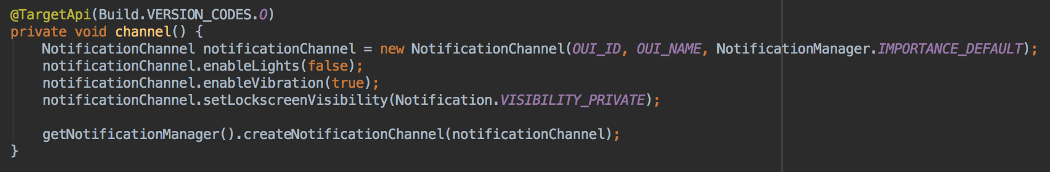

Code Snippet 21 NotifyMeHelper.java, Client App

* + 1. Holder
       1. MenuHolder.java

Menu holder sets the data of recycler view in menu detail activity. Information includes dish name, image, description and price of the item.

* + - 1. OrderHolder.java

Order holder contains the recycler view layout of order history activity. List of information includes order ID, order status, total price and table number.

* + - 1. ProductHolder.java

Product holder, holds recycler view layout of menu list activity. Menu list holds categories of menu items including name and image.

* + - 1. RestaurantHolder.java

Restaurant holder, holds restaurants that are available to view menu items from. Recycler view contains a list of available restaurants including its name and image.

* + - 1. ReviewHolder.java

Review holder contains information about reviews users made on a particular dish. Star rating, comment and username.

* + 1. Interaction
       1. FirebaseMessage.java

Firebase messaging class extends Firebase cloud messaging service. The code snippet below shows a function sendNotice26AboveApi which sets the remote notification. Once an order is placed remoteAPI will send a notification to server, alerting them of new orders.

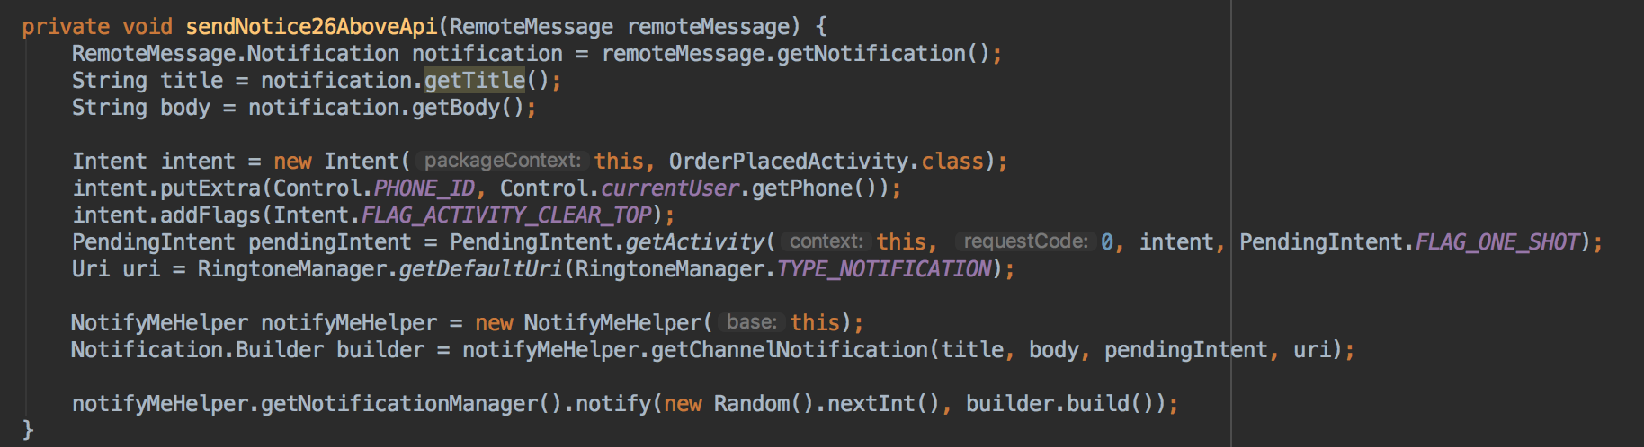

Code Snippet 22 FirebaseMessage.java, Client App

Notification title and body are stored in a JSON format and defined by using advanced rest client software as followed:

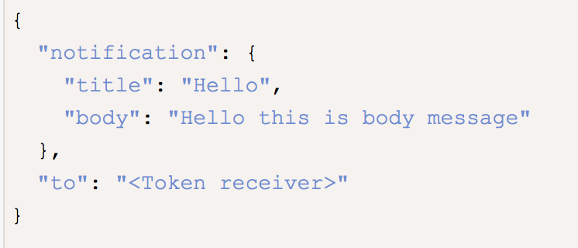

Figure 23 Advanced Rest Client

* + - 1. FirebaseService.java

Firebase service class retrieves tokens and sets if not already current user a new token. This token provides an authentication communication link between client and server application when making call responses.

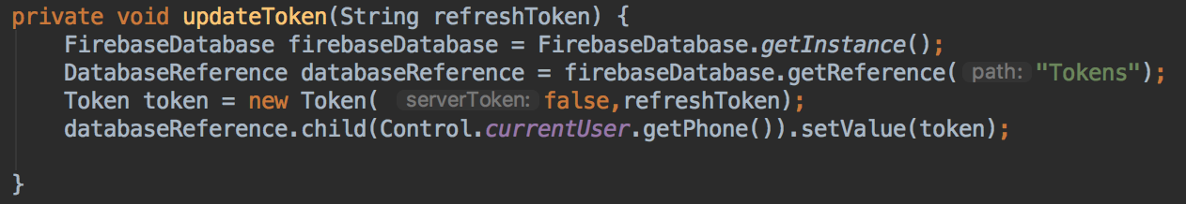

Code Snippet 23 FirebaseService.java, Client App

* + 1. Model

Model package contains java files to get and set data from database. It acts as a temporary storage facility before the data is sets to a new value or retrieves a value. Below discusses some model files that are implemented to this application.

* + - 1. MakeOrder.java

Contains getters and setters of orders that are made to retrieve data from firebase. A list of items that are makes an order are listed below.

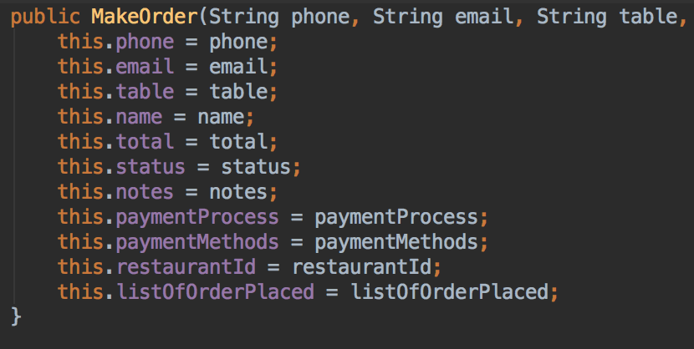

Code Snippet 24 MakeOrder.java, Client App

* + - 1. Menu.java

Menu model contains getters and setters of menu details activity.

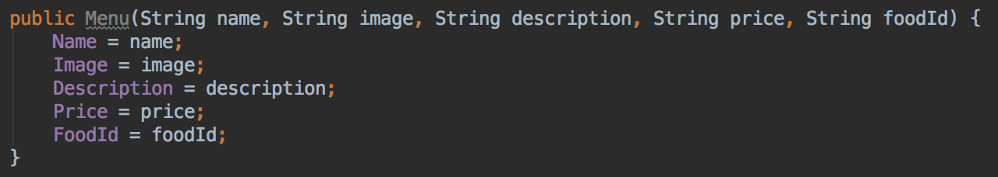

Code Snippet 25 Menu.java, Client App

* + - 1. Response.java

This java class shows implementation of and usage of advanced REST client API. This API tests interaction between client and server giving a success true or success false response.

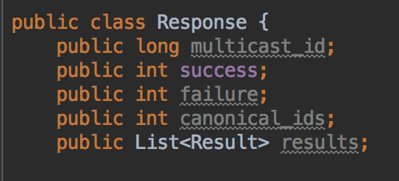

Code Snippet 26 Response.java, Client App

Using advance REST Client API a POST that requires authorization key from the server, a request is made resulting in a response.

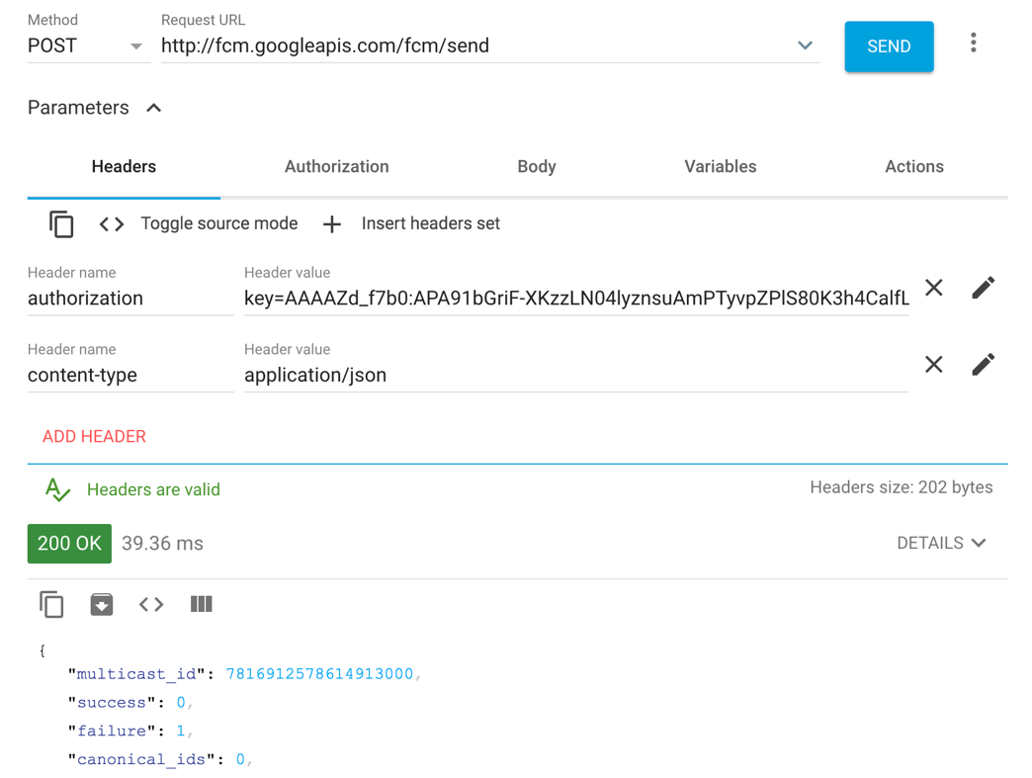

Figure 24 Advanced REST Client FCM

* + - 1. User.java

User model sets IsStaff variable to default false. Any new user registered will be under the category of customer only.

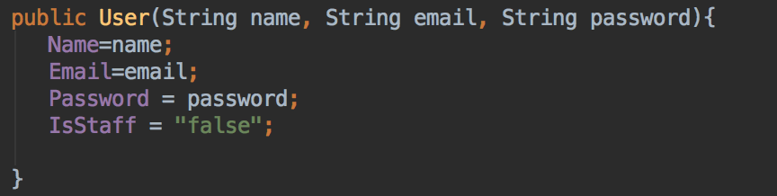

Code Snippet 27 User.java, Client App

* 1. Server Application Implementation
     1. Activity
        1. HomeActivity.java

Home activity class, functions including select image from users device image gallery, upload image and adding new products to the menu. Select function is implemented as followed, Intent.createChooser opens devices gallery to select a certain image that the user chooses.

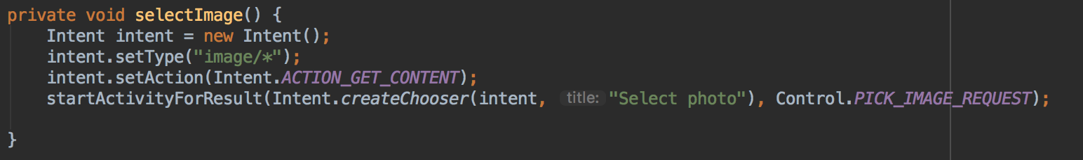

Code Snippet 28 HomeActivity.java, Server App

Upload image function uses firebase storage reference to upload a selected image to firebase storage. addOnSSuccessListener returns a success message of upload completetion. addOnFailureListener returns a failure message of image. addOnProgressListener shows the user a progress bar of the upload status.

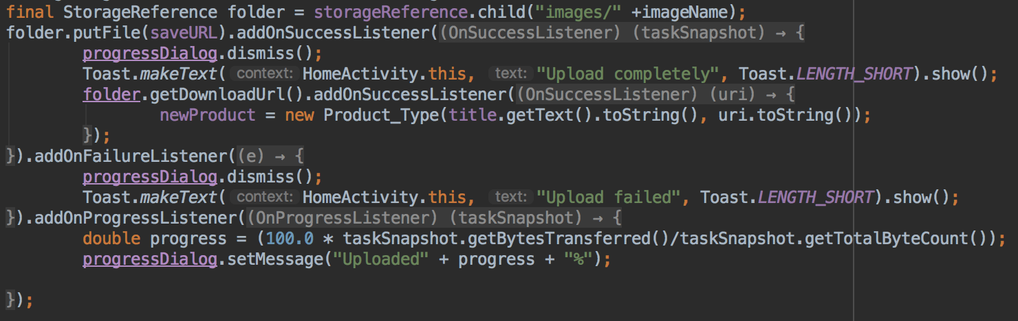

Code Snippet 29 HomeActivity.java, Server App

* + - 1. MenuListActivity.java

Menu list activity also performs similar functionality as home activity. Operations includes image, name, description and price updates. Users can also delete a dish item by removing menu item ID from firebase database.

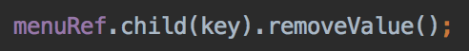

Code Snippet 30 MenuListActivity.java, Server App

* + - 1. OrdersPlacedActivity.java

This activity shows all orders that have been made by the client application. It has the ability to change order status from sent to kitchen, cooking and served. Once an order status is changed sendStatus function is called which sends a notification to the client application.

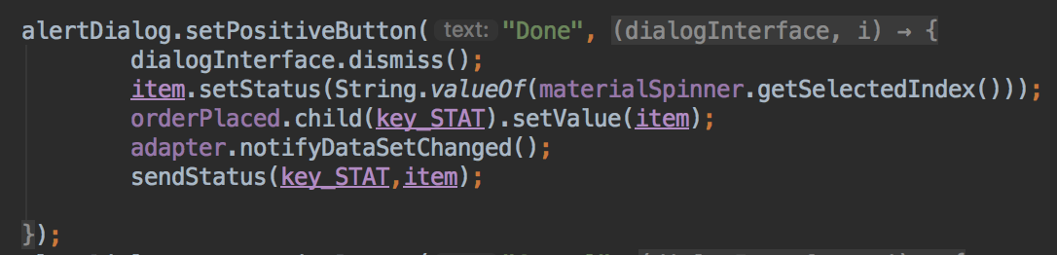

Code Snippet 31 OrderPlacedActivity.java, Server App

Notification is sent by call responses using retro fit API service. This allows quick responses between server and client communication.

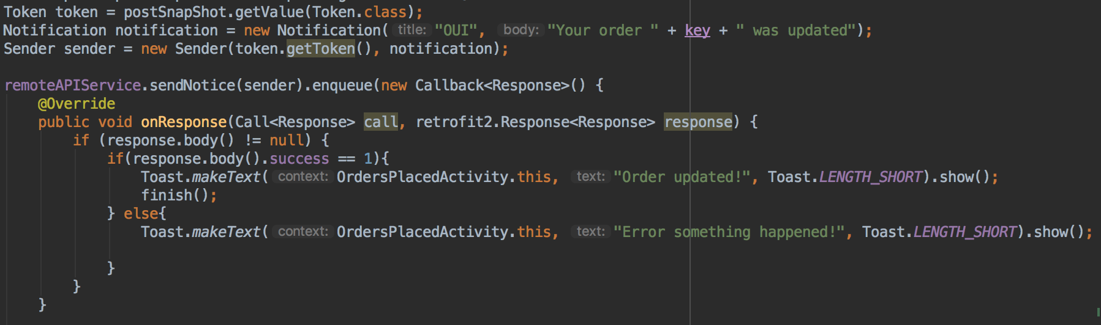

Code Snippet 32 OrderPlacedActivity.java, Server App

* + 1. Control
       1. Control.java

Order date function is implemented using Calendar utility. Date format is set to DD-MM-YYY HH:MM.

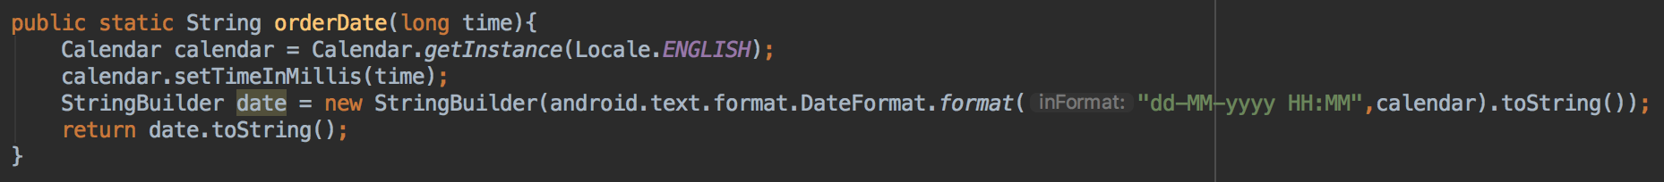

Code Snippet 33 Control.java, Server App

* + 1. Holder
       1. MenuHolder.java

Menu holder java class contains the recycler view of each dish item. This class also implements onClickListener which gives users actions to update or delete an item. onCreateContextMenu sets these actions.

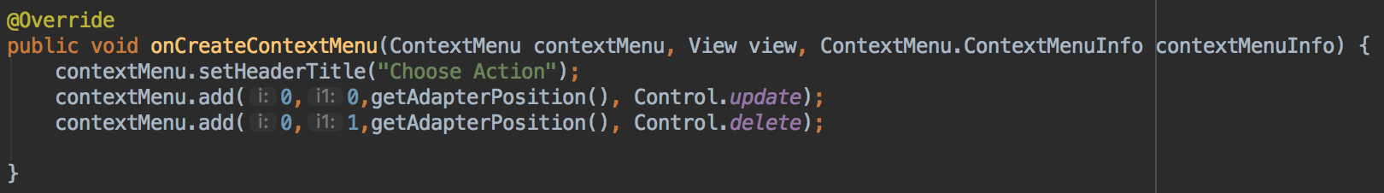

Code Snippet 34 MenuHolder.java, Server App

* 1. Back End Implementation
     1. Database Structure



Table 9 Restaurant Data Structure Diagram

Restaurant operation section structure contains tables that include restaurant information, product type, menu item and rating. Each restaurant contains many menu items, product type and rating.

Restaurant entity includes a restaurant ID that uniquely identifies a restaurant when retrieving a certain restaurants data. Restaurant IDs are used to generate the QR code using a QR code generator tool. This entity also contains restaurant name and image that users are able to view when selecting an available restaurant.

Product type entity provides data about different categories that are available on the menu. It contains information of the name and image of different categories of dishes that a restaurant has. A unique identification key is given to product type, this key is then used as a foreign key to menu items entity.

Menu item entity provides information about each dish that is on the menu. Item ID is unique and is called when users want to view information about each dish. Name, description, price and image are all attributes that are stored in menu item entity. Menu items also contains the foreign key of restaurant ID and product ID. Each restaurant contains many menu items and each category contains many dishes.

Rating entity stores users input on each dishes. Reviews are set according to star rating, comment and foreign key of users, restaurant and menu items. Each rating has a unique ID, each restaurant contains many ratings for each menu item. Each user can make many reviews for many dishes and each dish contains many reviews.



Table 10 Order Placed Data Structure Diagram

Orders placed data structure section contains user, list of orders and order placed entities. Each entity contains a unique identity key, users are identified using these keys. User details can be retrieved by calling a user ID. Users store information including their name, username, user phone, email, password and a Boolean value to indicate if a user is a staff or a customer.

Order placed entity consists of order comments, payment process, table number, order status and payment methods. Additionally this entity incorporates many foreign keys including user ID, list ID and rest ID. Users can write comments into their order to customize their own order. One order can only process one transaction method and process state. Payment process is defined by either paid or unpaid and payment methods are considered by either PayPal or cash transaction. Table numbers are also set by the user when making an order. Each order status is set to ‘0’ when an order is placed by a user, this status will be changed by a staff member. Users can place many orders, containing many different dishes. Restaurants can receive many incoming order.

List of orders entity consists of list ID, quantity of item, price and item ID attributes. Quantity depends on the amount of each dish is placed in an order. Price is calculated by the quantity of a certain dish by adding the price per dish cost.

* + 1. Firebase

Firebase is a NoSQL database storage facility, it allows data change to be operated smoothly without the need to update the system. Firebase can provide many functionalities including authorization, real-time data retrieval, firebase messaging and image database storage.

Image database storage is used in the server application, this tool allows restaurant managers to upload an image from their device to firebase storage. Once it is stored here data can be read from both client and server application instantaneously. These images can be deleted and re-uploaded.

The structure of firebase is shown below, each restaurant has a unique ID which contains information on order placed, menu, product type and reviews. Server tokens are stored based on if the user is a staff or user. If a user is a restaurant customer, server token is set to false while if the user is a staff, server token is set to true.

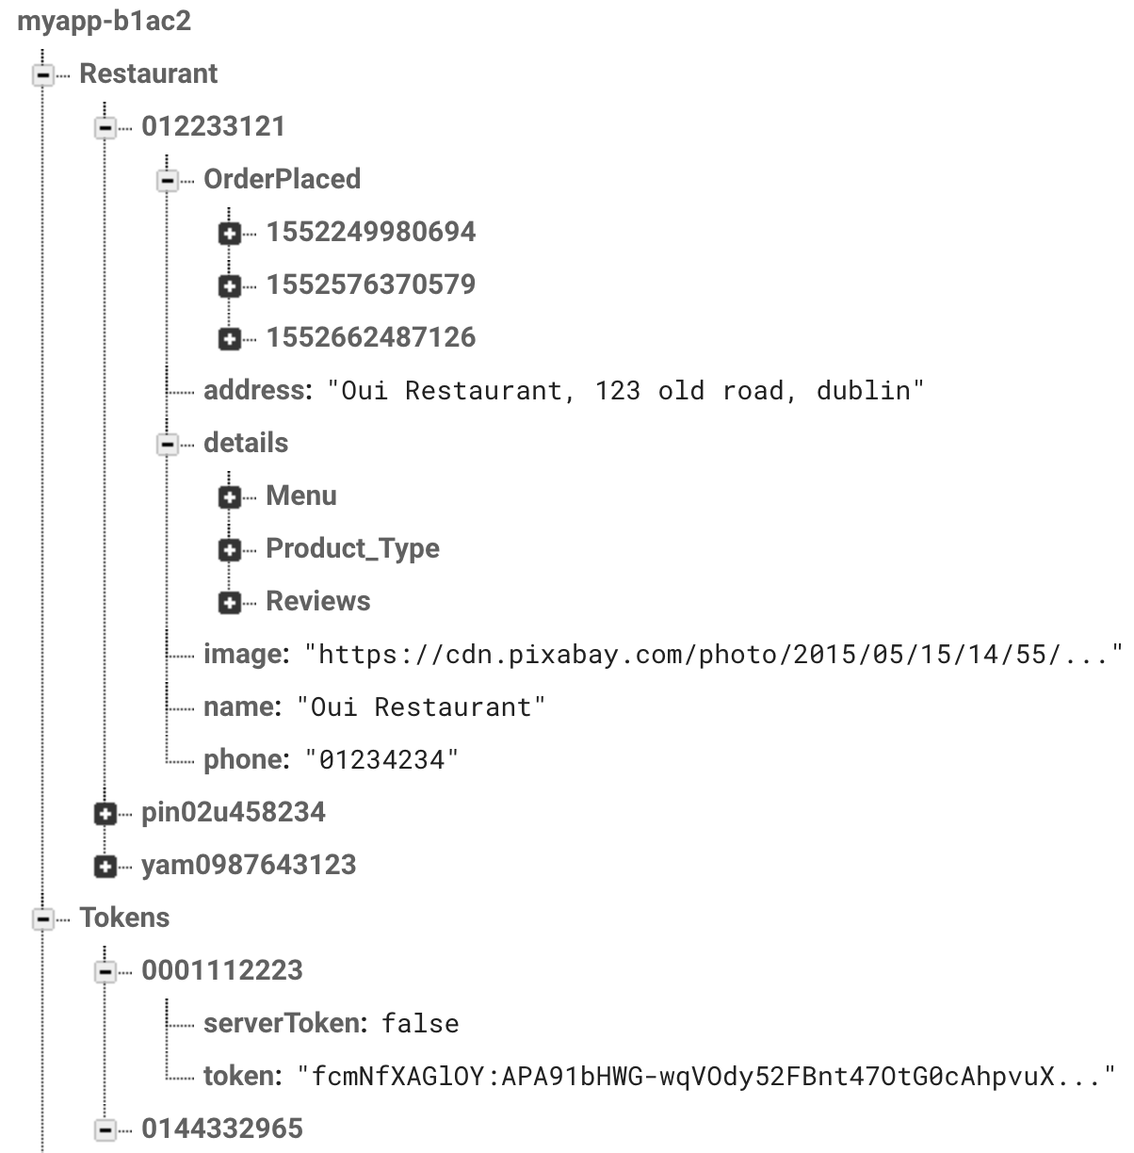

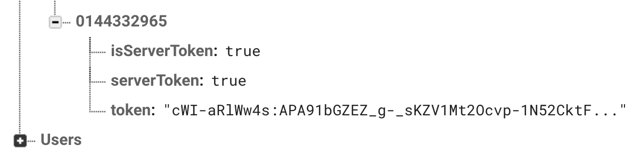

Figure 25 Firebase Database Structure

Firebase performs multiple functionalities such as authentication, firebase cloud messaging and firebase storage. To integrate these functions the following gradle implementations are defined.

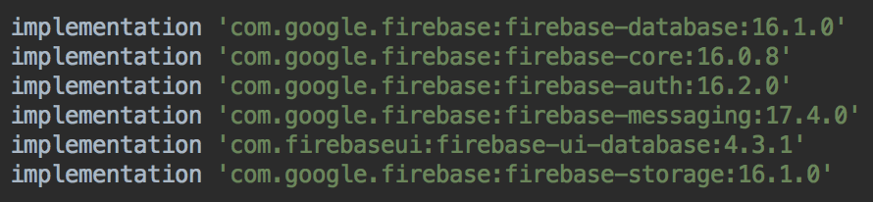

Code Snippet 35 Firebase implementation

* + 1. SQLite DB Browser



Figure 26 DB Browser for SQLite

4.5 Flow board of Activities

4.5.1 Client Application

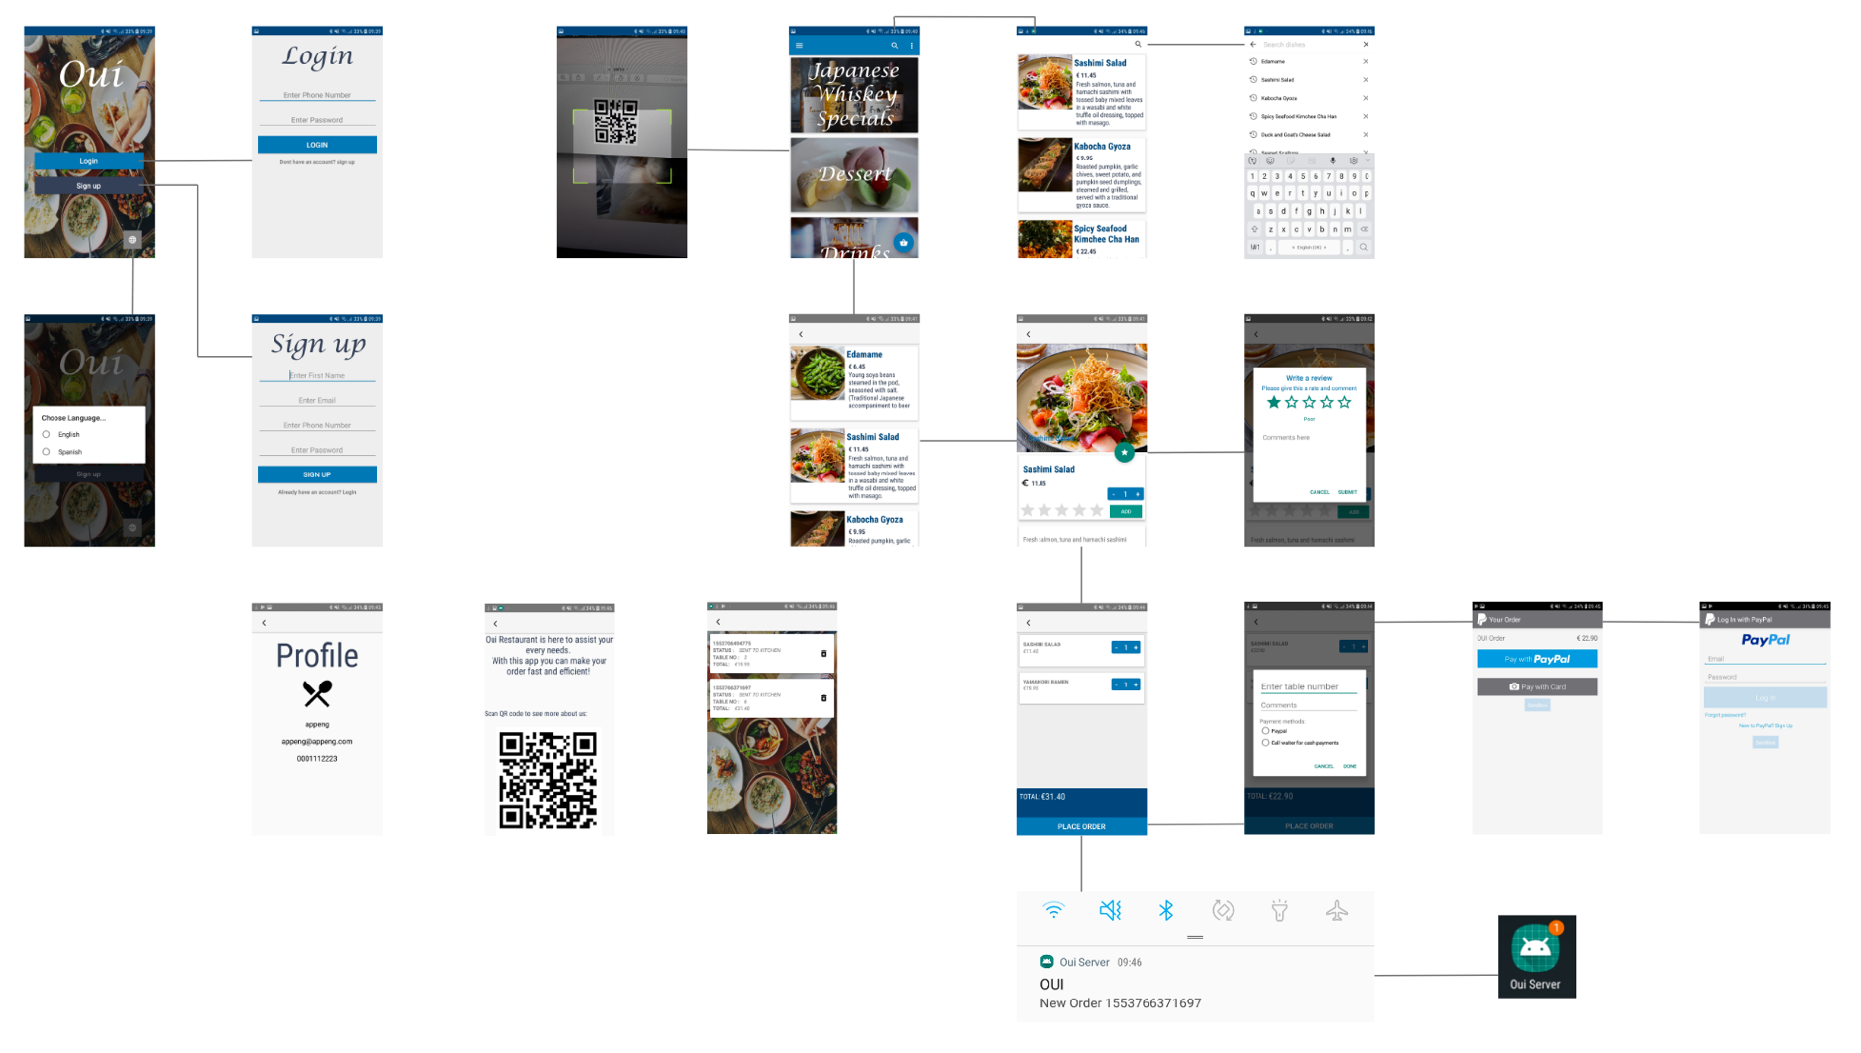

Figure 27 Flow Board of Client Application

4.5.1 Server Application

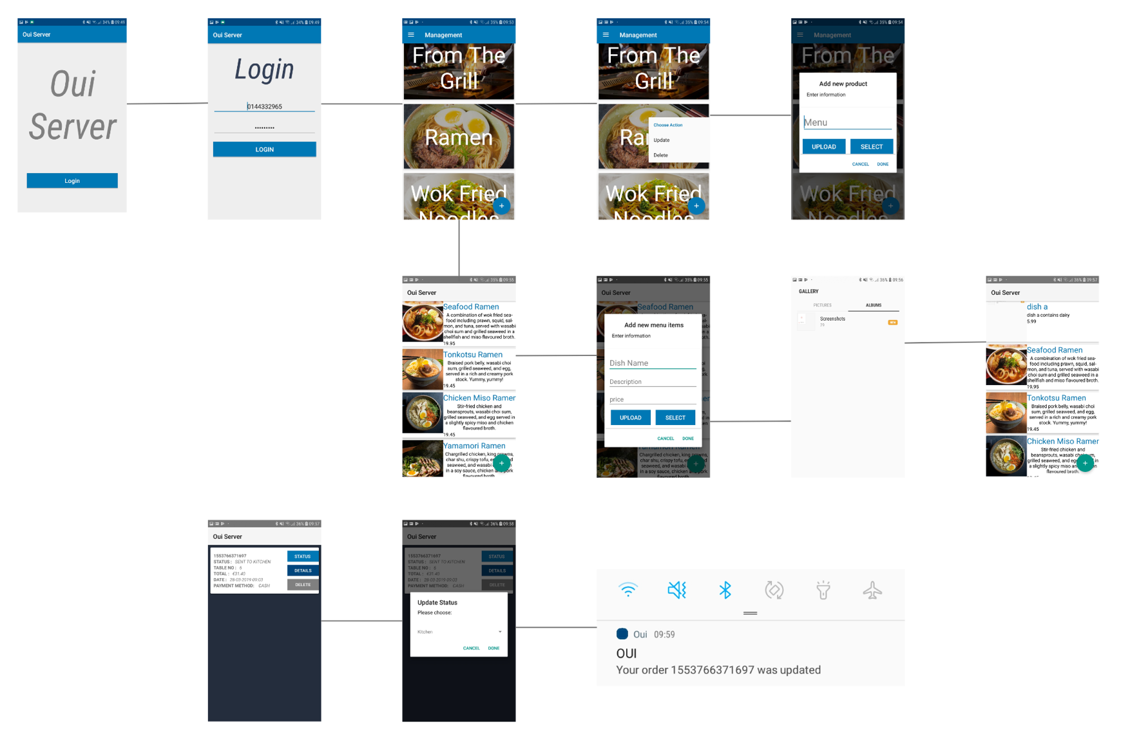

Figure 28 Flow Board of Server Application

1. System Validation
   1. Testing

5.1.1 Client Application Testing

* Think aloud protocol
* Usability and Accessibility testing
* Notification testing
  + 1. Server Application Testing
  1. Demonstration
* Youtube video link
* GitHub repository

1. Project Plan

* Progression from interim to final product
* What changed during the process of development
* What to change/ done differently if developed again

1. Conclusion

* Project summary
* Future development

# Bibliography

|  |  |
| --- | --- |
| [1] | D. A. Koutroumanis, “Technology’s effect on hotels and restaurants: Building a strategic competitive advantage.,” *Journal of Applied Business and Economics,* vol. 12, no. 1, pp. 72-80, 2011. |
| [2] | B. Wong, “Points of View, Color blindness,” *Nature methods,* vol. 8, no. 6, p. 441, 2010 . |
| [3] | J. Wirtz, B. M. Noone and S. E. Kimes, “The Effect of Perceived Control on Consumer Responses to Service Encounter Pace: A Revenue Management Perspective,” SAGE, Ithaca, 2012. |
| [4] | C. I. Ltd, “Customer Experience Lifecycle Audit,” Customer Input, 1 January 2011. [Online]. Available: http://www.customerinput.com/customerexperience/experience-lifecycle-audit/. [Accessed 1 March 2019]. |
| [5] | rangelov@orderwizard.mobi., “OrderWizard,” 19 September 2013. [Online]. Available: https://play.google.com/store/apps/details?id=mobi.orderwizard&hl=en_US. |
| [6] | Q. Orders, “Quick Orders your personal waiter,” Quick Order Inc., 26 May 2015. [Online]. Available: http://quickorders.net/#features. [Accessed 29 March 2019]. |
| [7] | g. zxing, “ ZXing 3.3.3 API. github,” [Online]. Available: https://zxing.github.io/zxing/apidocs/. |
| [8] | PayPal, “PayPal Developer,” [Online]. Available: https://developer.paypal.com/. |
| [9] | W. Jobe, “Native Apps vs. Mobile Web Apps,” International Journal of Interactive Mobile Technologies, Stockholm, 2013. |
| [10] | B. Stonehem, Google Android Firebase: Learning the Basics., usa: First Rank Publishing, 2016. |
| [11] | D. Zelenchuk, “AndroidX Test Library,” InAndroid Espresso Revealed, Apress, Berkeley, 2019. |
| [12] | M. Wolfson, “Converting your Android App to Jetpack,” A Medium Corporation, 27 November 2018. [Online]. Available: https://medium.com/google-developer-experts/converting-your-android-app-to-jetpack-85aecfce34d3. [Accessed 29 March 2019]. |
| [13] | T. Bohling, D. Bowman, S. LaValle, V. Mittal, D. Narayandas, G. Ramani and R. Varadarajan, “CRM Implementation: Effectiveness Issues and Insights,” SAGE, Maryland, 2006. |
| [14] | J. Hutchins, “Machine Translation and Human Translation: In Competition or in Complementation?,” *International Journal of Translation,,* vol. 13, no. 1, pp. 6-19, 2001. |
| [15] | J. Highsmith and M. Fowler, “The Agile Manifesto,” Software Development, Utah, 2001. |
| [16] | J. GULLIKSEN, B. GORANSSON, I. BOIVIE, S. BLOMKVIST, J. PERSSON and A. CAJANDER, “Key principles for user-centred systems design,” *BEHAVIOUR & INFORMATION TECHNOLOGY,* vol. 22, no. 6, p. 397–409, 2003. |